DATABASE SYSTEM

COMPONENT 2 (70%)

Title: Cars4U vehicle hire company (SECURITY)

**Student Name:** Aastha Niraula

**Student id:** c7227225

**CONTENTS**

Table of Contents

INTRODUCTION TO THE REPORT 3

Task 1: Implementation and Testing 4

1.1 Implementation of trigger 1 4

Trigger for Customer Auditing (Data INSERT, UPDATE, DELETE) 4

1.2. Testing of Trigger 1 6

1.3 Additional Trigger for Customer and Insurance table 8

Maintaining Data Integrity of Constraints 8

Testing of Additional Trigger 9

1.4 Implementation of trigger 2 11

Trigger for signing contract on Company Holidays 11

1.5 Testing of trigger 2 12

Task 2. Application Builder Report 13

1. SQL Apex Report Number: 1 13

2. SQL Apex Report Number: 2 14

3. SQL Apex Report Number: 3 15

4. SQL Apex Report Number: 4 16

Task 3. Application Builder Forms 17

Home Page 17

1. Master Detail for Customer, Hire and Contract 18

Creating Sequence and Trigger 19

Sequence and trigger for Customer ID 19

Sequence and trigger for Hire Number 20

CRUD Functionality 21

2. Master Detail for Vehicle, Hire and Invoice 24

3. Dashboard for Vehicle, Hire and Invoice 25

4. Dashboard for Customer based on Gender 27

5. Using APEX Functionality 28

a. Using Radio Group 28

b. Using Popup LOV and adding SQL command 29

6. Required Fields 32

7. User login 33

Creating Users 33

Editing the Actions 34

Bibliography 36

Appendixes 37

TASK1: 37

Trigger 1 37

Testing 38

Additional Trigger 38

Testing 38

Trigger 2 39

Testing 39

TASK 2: 39

Report1 39

Report2 39

Report3 40

Report4 40

SEQUENCE AND TRIGGERS 40

# INTRODUCTION TO THE REPORT

The report is divided into three tasks, each consists of its own functionality and has its own unique requirements. For this assessment, I chose Option 1 which is “The security of your data by implementing server and client-side solutions”. As per the requirements triggers, reports, master details, dashboards have been implemented.

The first task contains two triggers along with an additional trigger to maintain data integrity in the table after applying the first trigger. The triggers are used in auditing Customer table, maintaining data integrity of constraints and raising an application error in case of Contract table where the condition is not fulfilled for Holidays. The testing codes for each trigger with the evidences is attached along with the trigger implementation.

Similarly, task two includes production of an application with the help of Application Builder for producing four SQL reports of advance and intermediate level. The detail function of each report is mentioned along with the SQL codes. Further validation of the work is done by including screenshots of output for each report.

Task three includes a home page for the application, two master details for different tables and CRUD functionality has been implemented. The tables used for first Master Detail are: Customer, Hire, Contract whereas for second: Vehicle, Hire and Invoice are used. Along with these, dashboards have also been created that includes bar, chart, pie chart, etc. In order to automatize the PKs two sequences has also been created along with the triggers. Variations is seen in terms of using APEX Functionality: LOV, Radio Buttons, etc. have been used. The application also includes reports and for maintaining security two users have been created, administrator and contributor where each user has different authentication rule.

# Task 1: Implementation and Testing

## 1.1 Implementation of trigger 1

### Trigger for Customer Auditing (Data INSERT, UPDATE, DELETE)

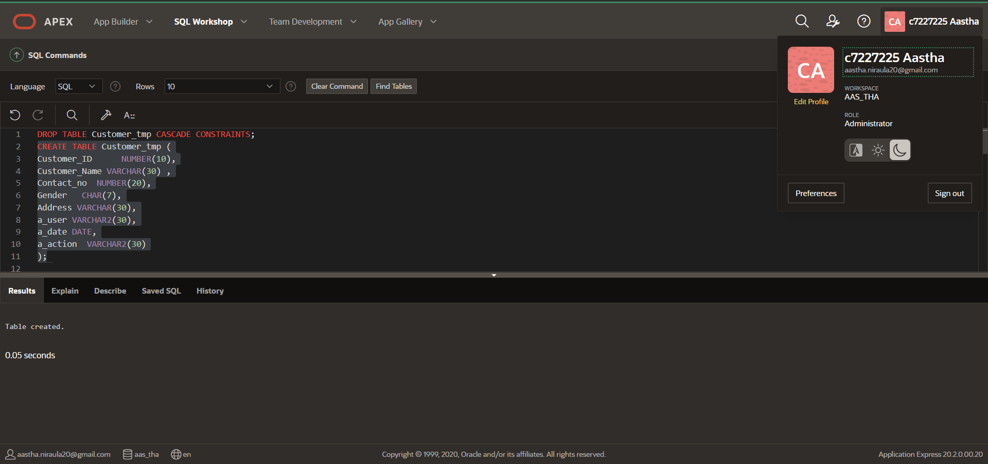

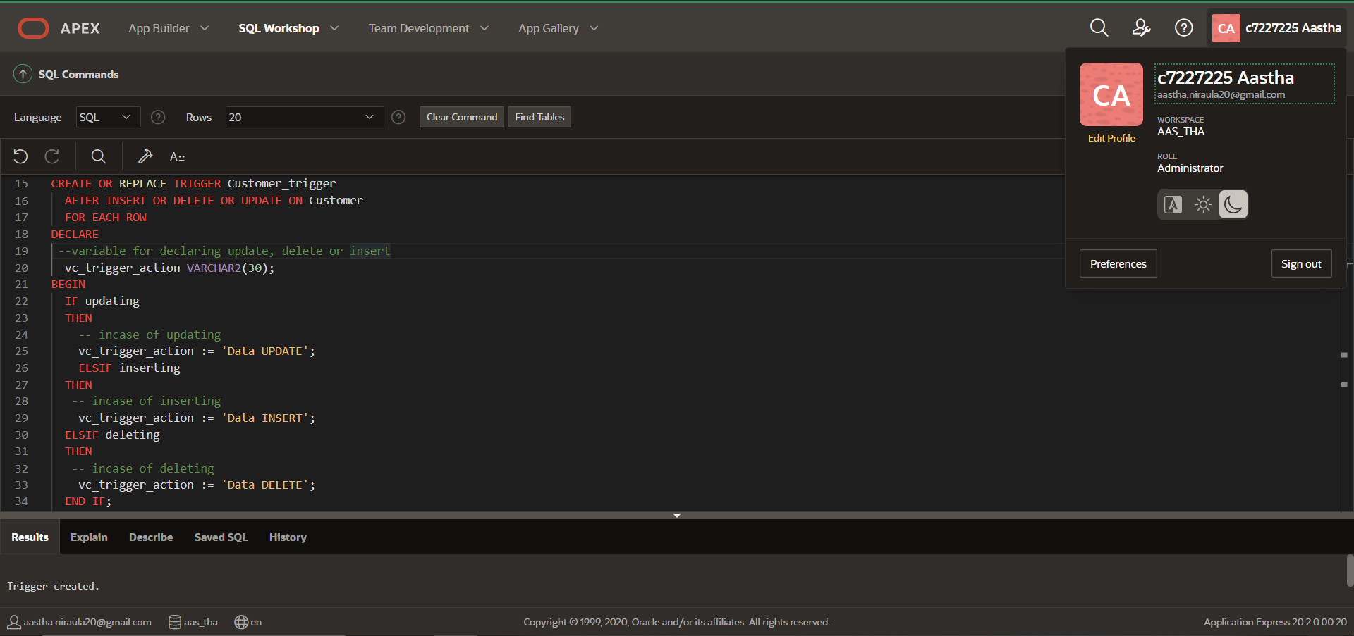

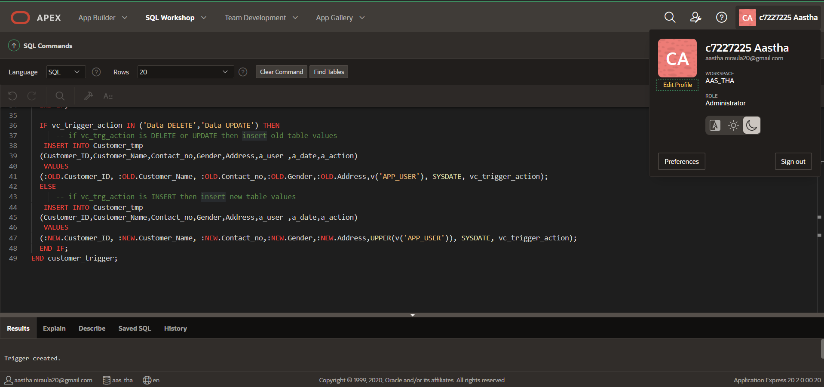

## 1.2. Testing of Trigger 1

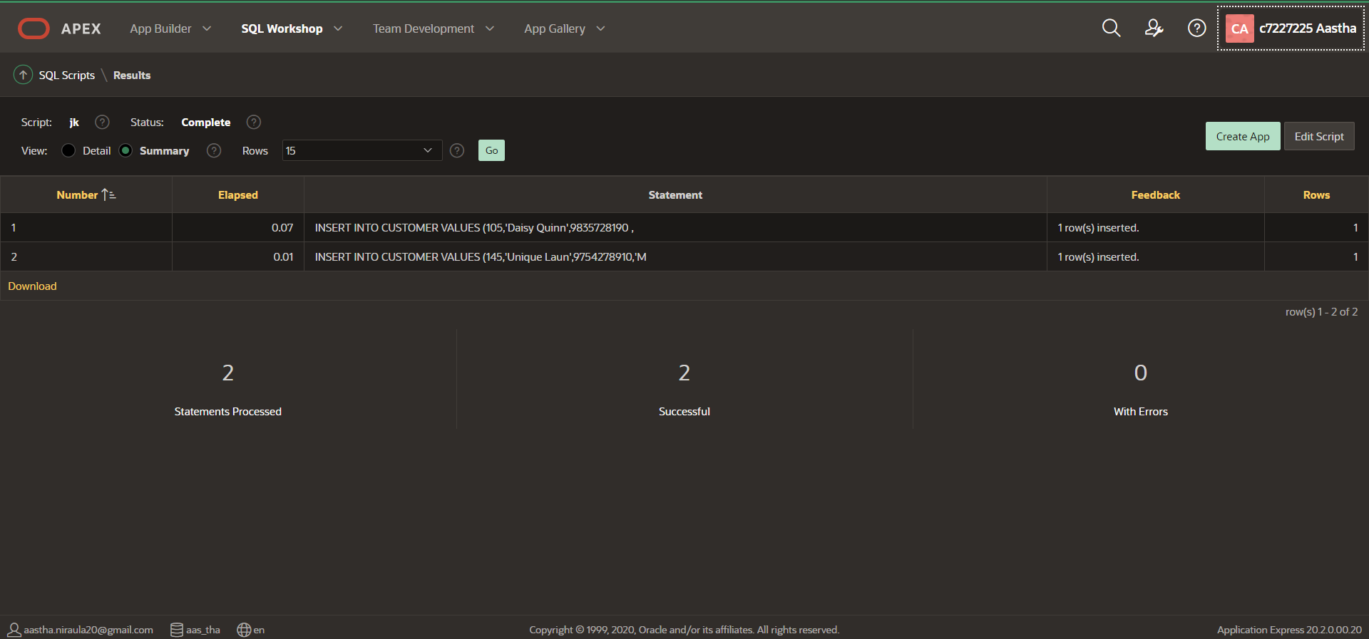

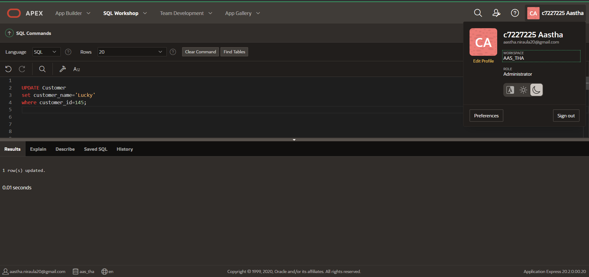

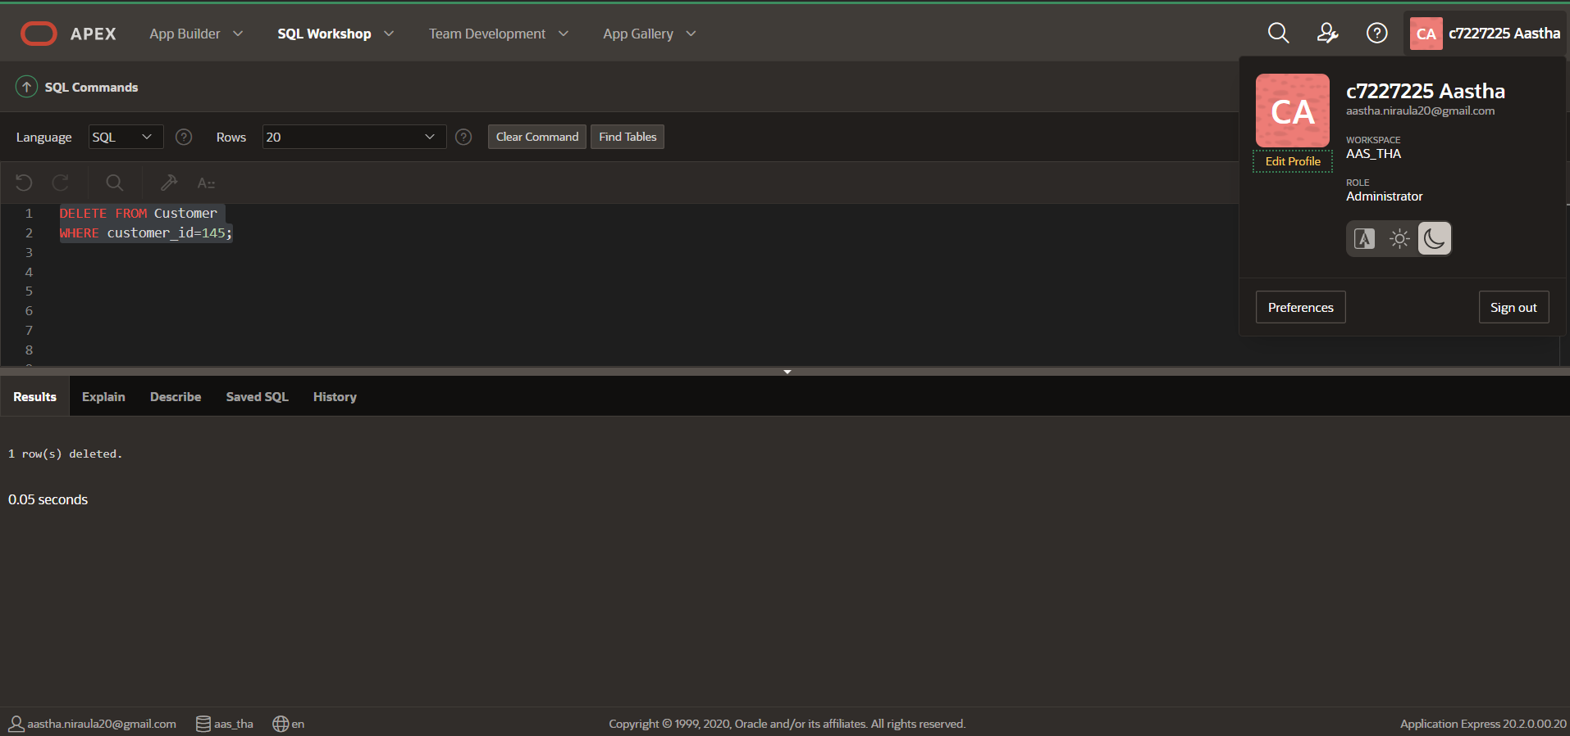

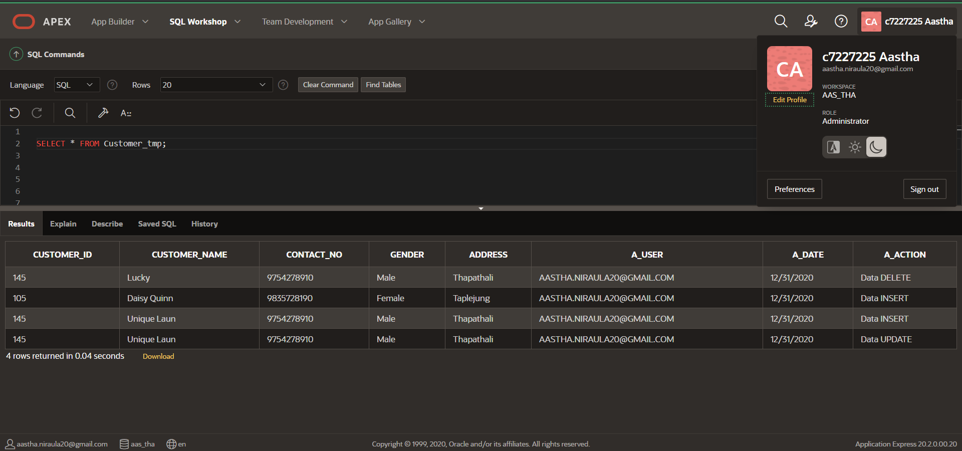

## 1.3 Additional Trigger for Customer and Insurance table

### Maintaining Data Integrity of Constraints

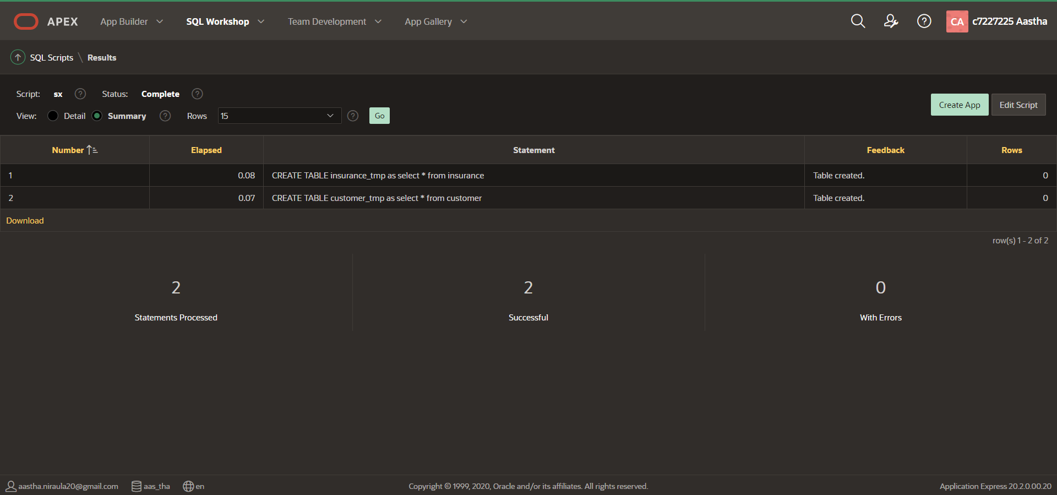

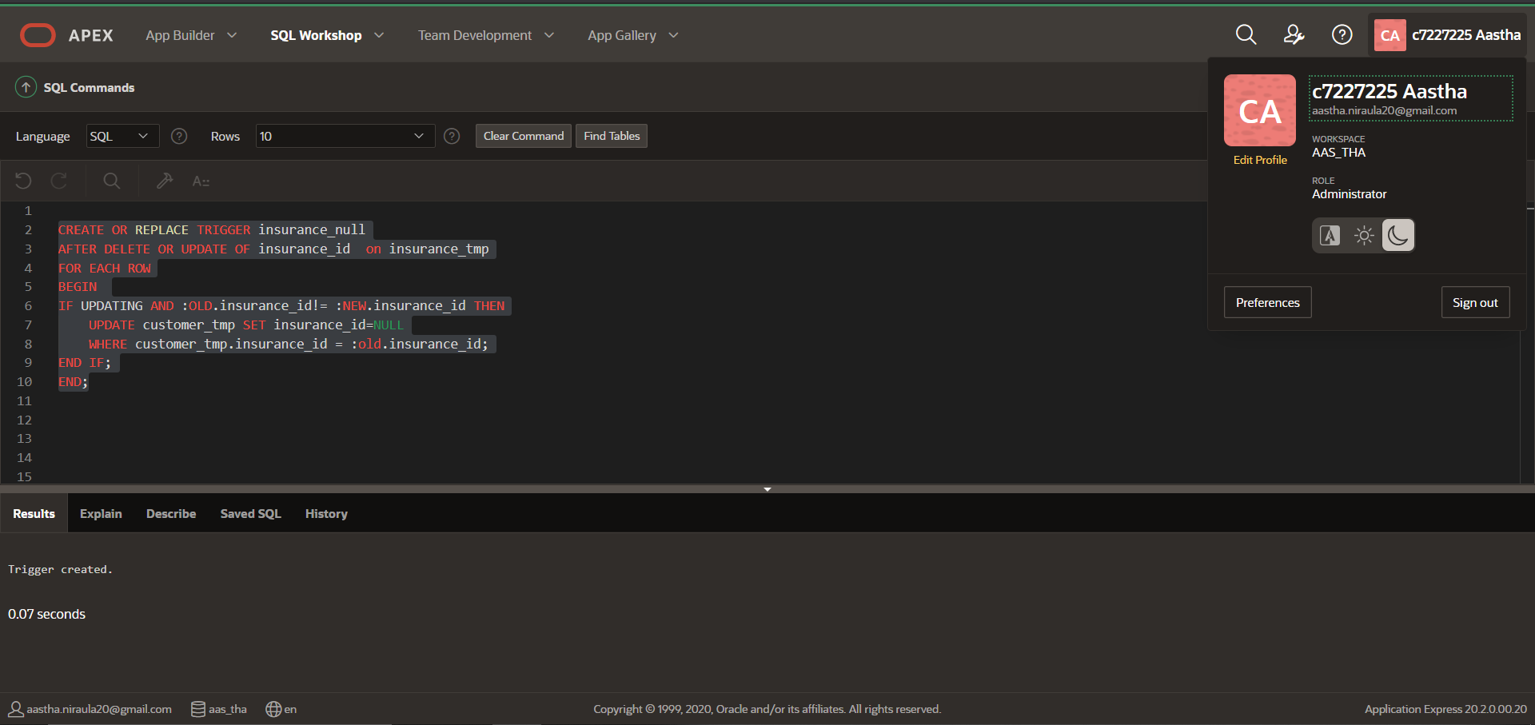

### Testing of Additional Trigger

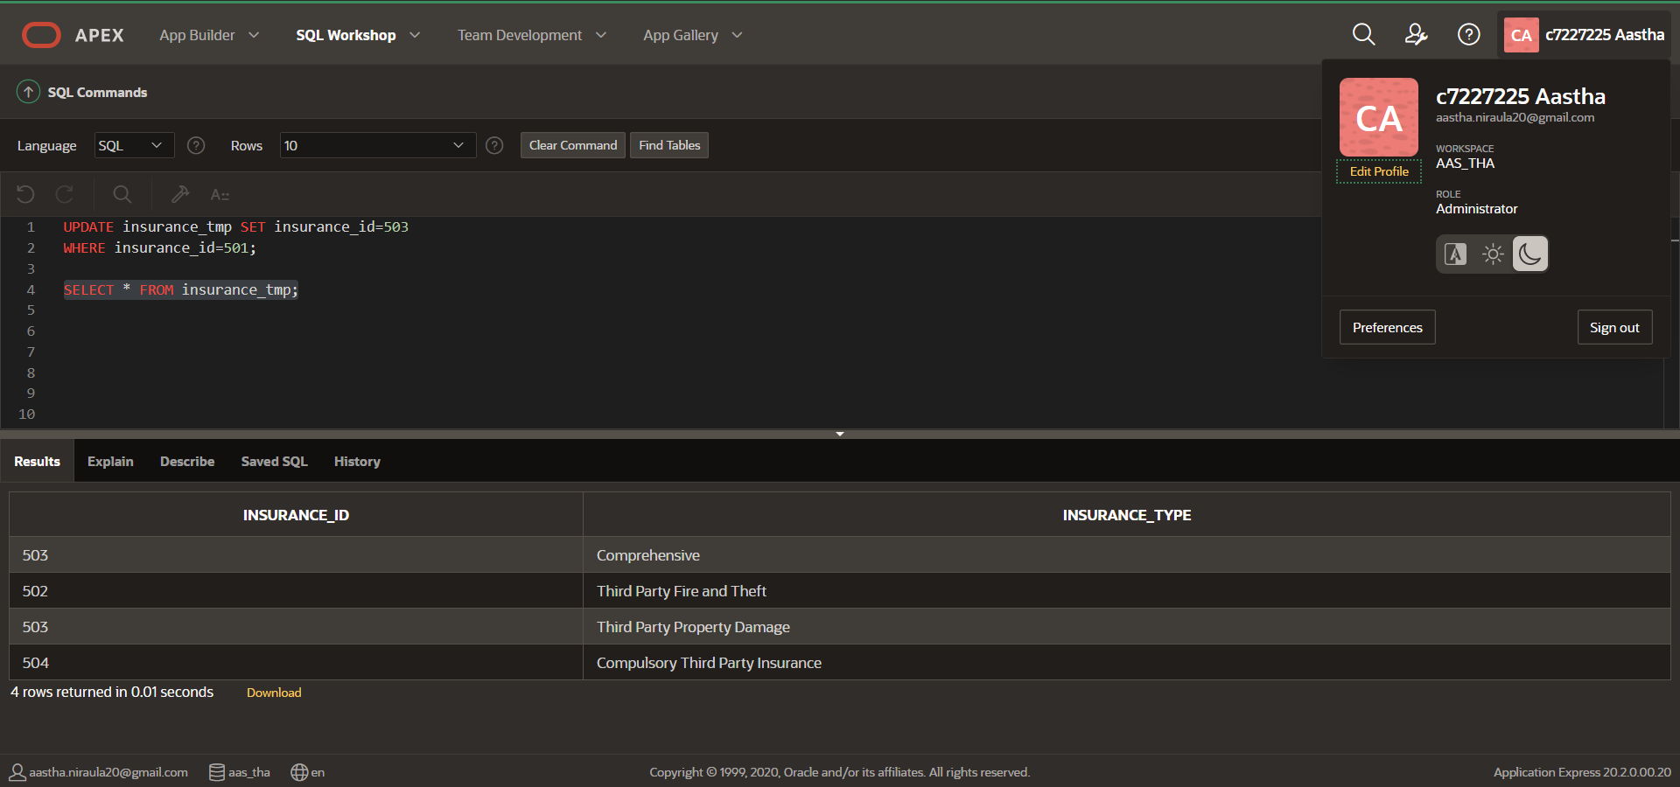

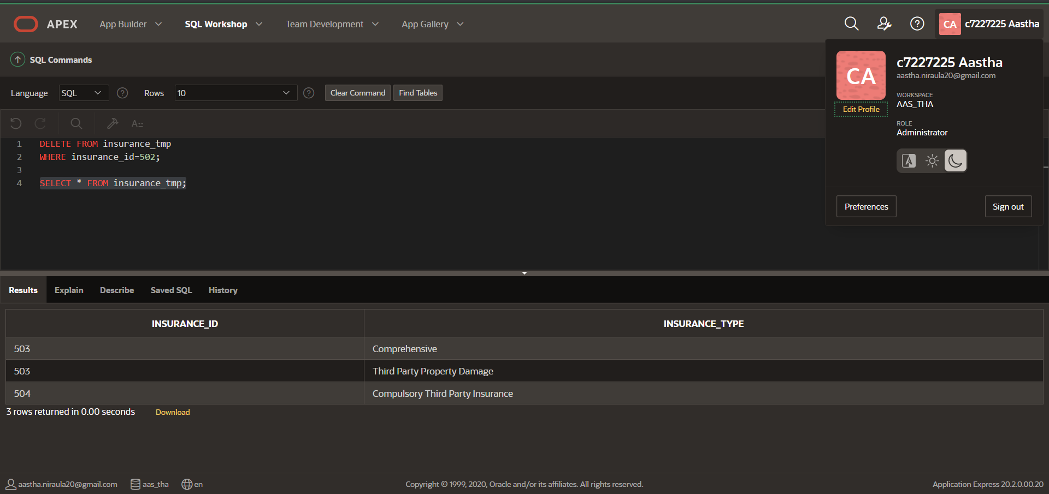

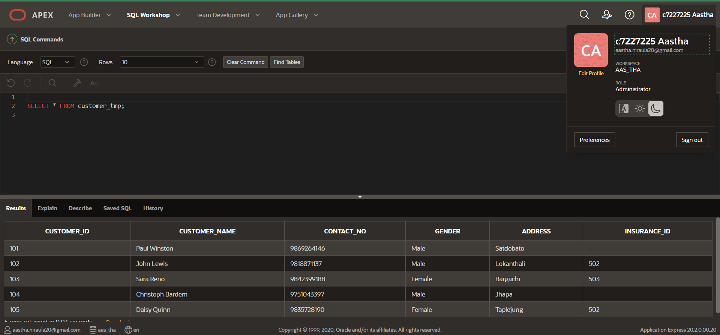

## 1.4 Implementation of trigger 2

### Trigger for signing contract on Company Holidays

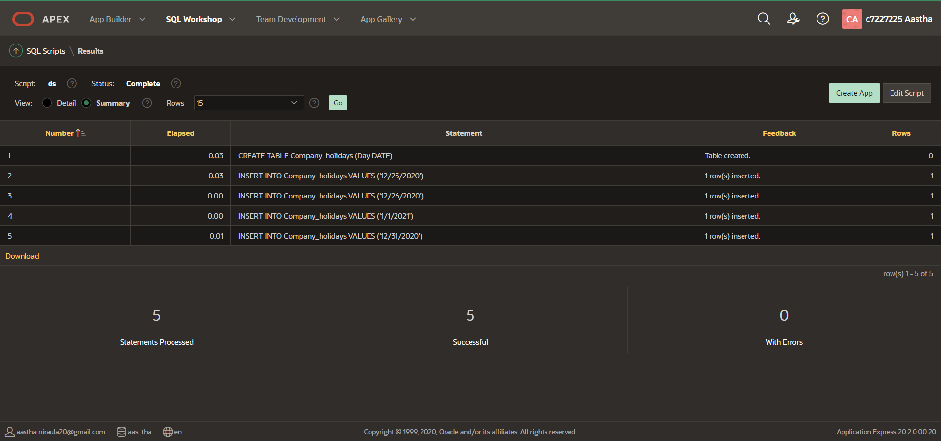

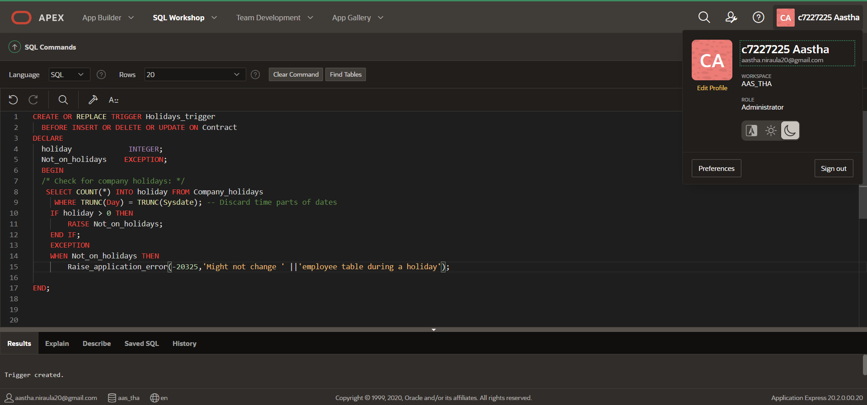

## 1.5 Testing of trigger 2

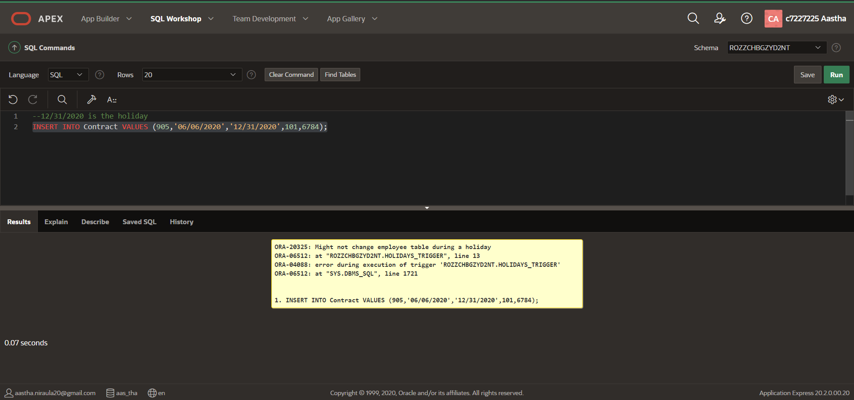

# Task 2. Application Builder Report

## 1. SQL Apex Report Number: 1

The report has included two tables Customer and Hire which takes the details of Customer who has hired a vehicle more than once and the details are ordered based on the hire days.

SELECT c.Customer_ID, c.Customer_name, h.hire_days

FROM Customer c, Hire h

WHERE c.customer_id = h.customer_id

AND hire_days >1

ORDER BY Hire_days ;

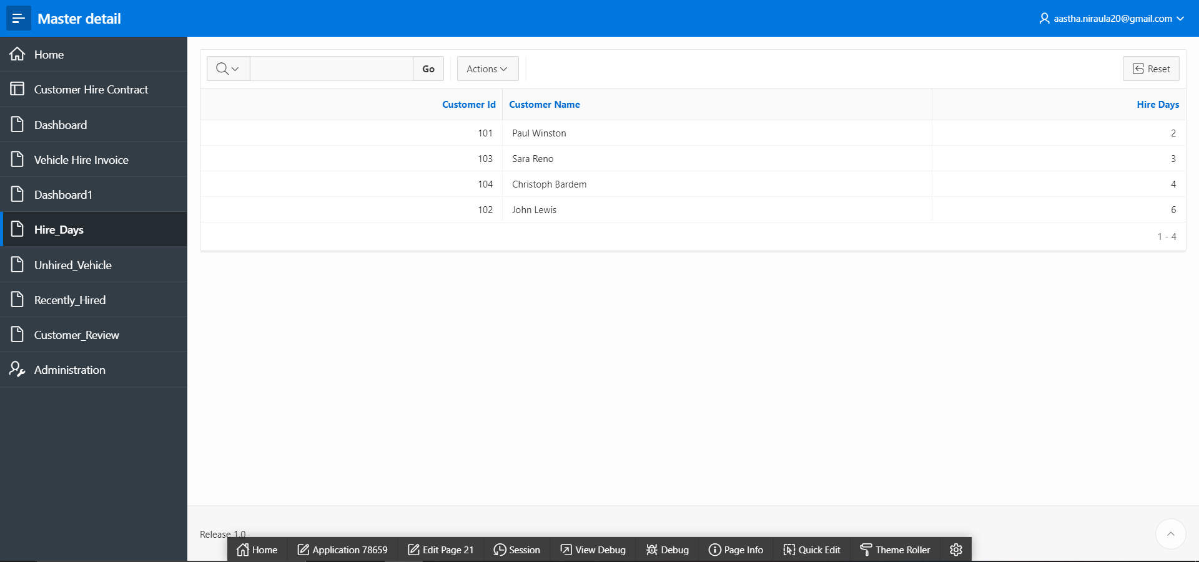

## 2. SQL Apex Report Number: 2

The report includes two tables’ vehicles and hire and applies the condition that if the vehicles have not been hired even once then the list is displayed for the vehicles that are not hired.

SELECT v.vehicle_no, v.classification, v.model, v.charge, h.hire_no

FROM vehicles v, hire h

WHERE h.hire_no (+) = v.hire_no

AND v.hire_no is NULL;

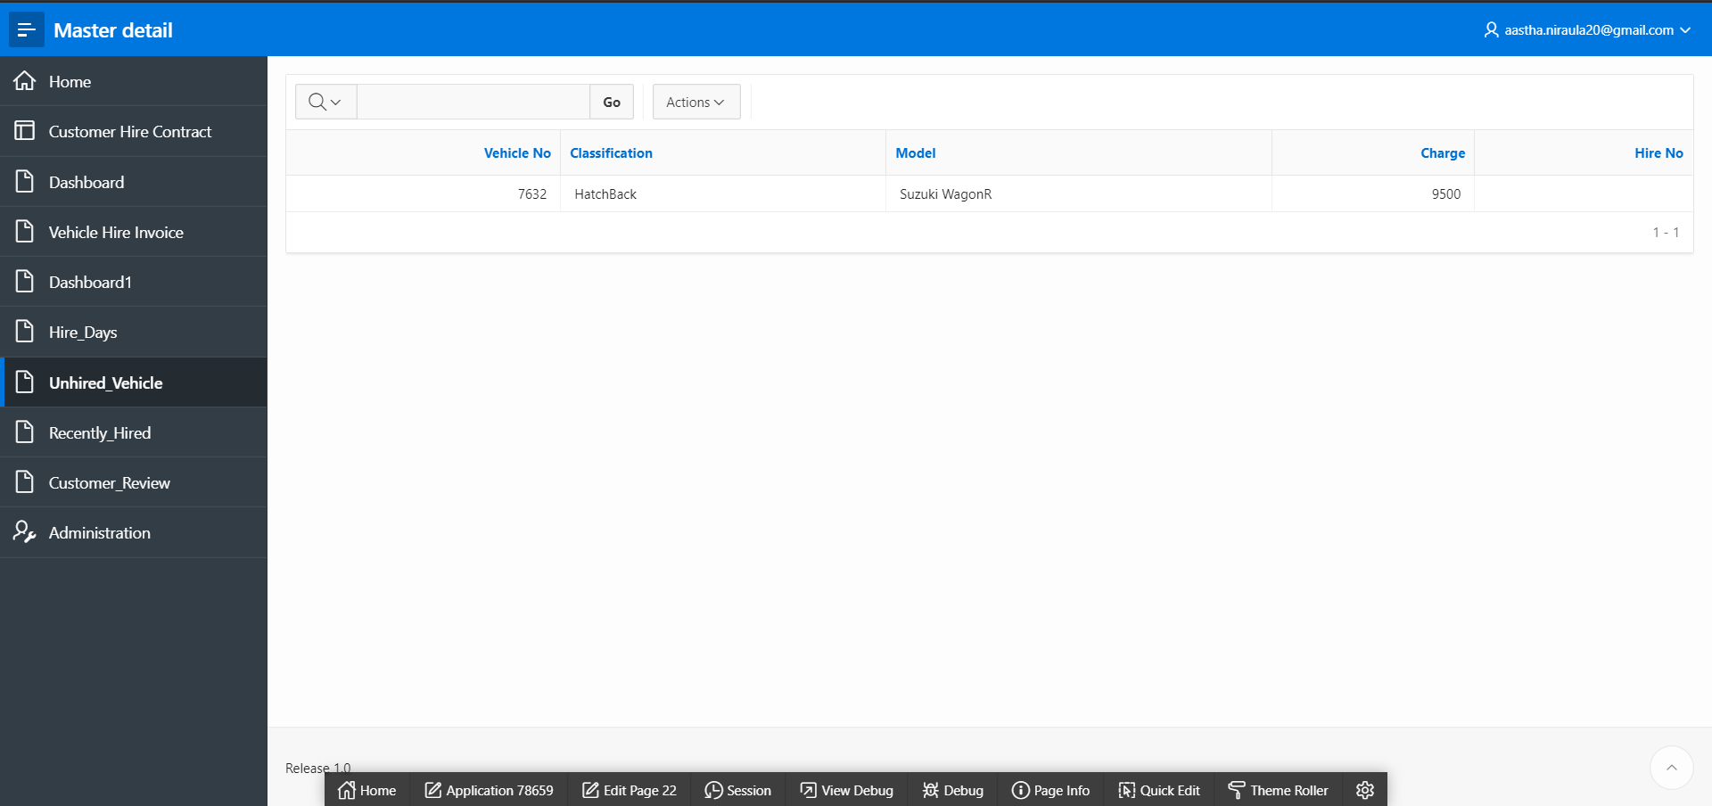

## 3. SQL Apex Report Number: 3

The report gives information about the vehicle that has been recently hired.

SELECT contract_no, start_date, customer_id

FROM Contract

WHERE (start_date, customer_id)

IN

(SELECT MAX(start_date), customer_id

FROM Contract

GROUP BY customer_id);

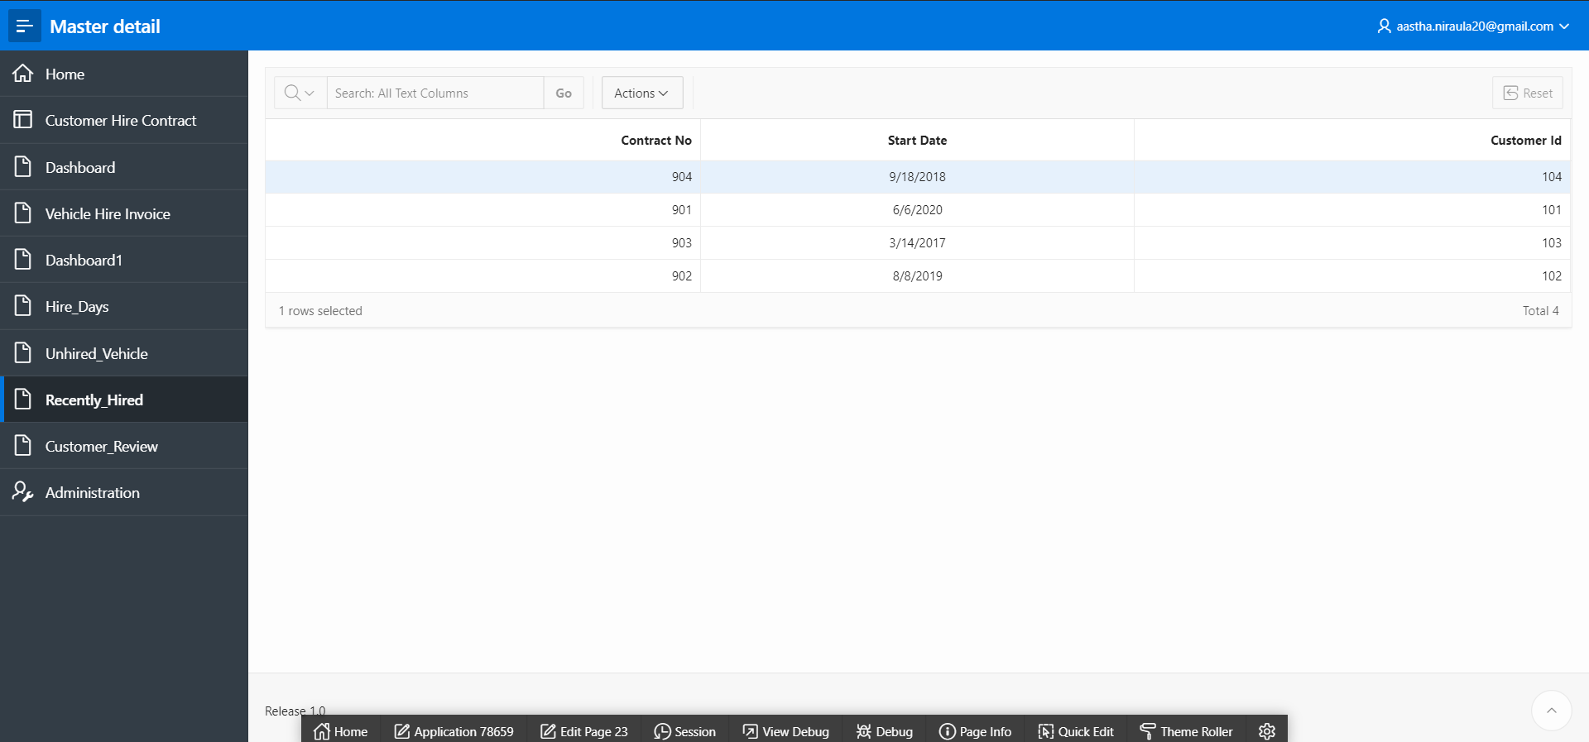

## 4. SQL Apex Report Number: 4

The report merges two tables Contract and Customer which helps in taking the review from the customers. The review date is recorded 2 months prior to the contract ending date.

SELECT ct.customer_id, c.customer_name, c.contact_no, ct.Contract_no, ct.end_date, add_months(end_date, 2) review_date

FROM contract ct INNER JOIN customer c

ON ct.customer_id=c.customer_id

ORDER BY add_months(end_date,2);

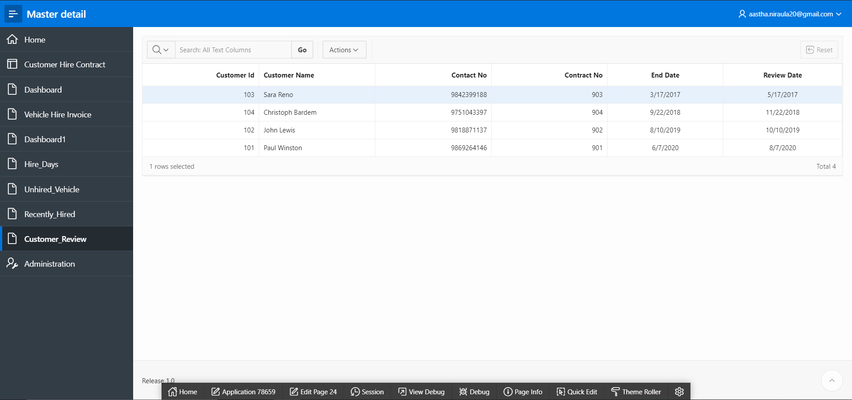

# Task 3. Application Builder Forms

## Home Page

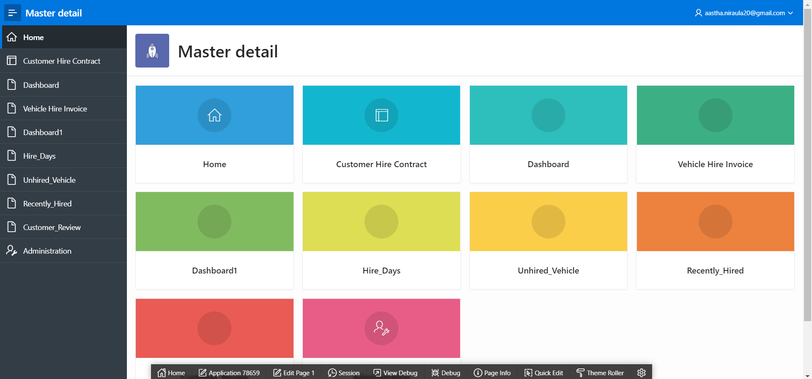

## 1. Master Detail for Customer, Hire and Contract

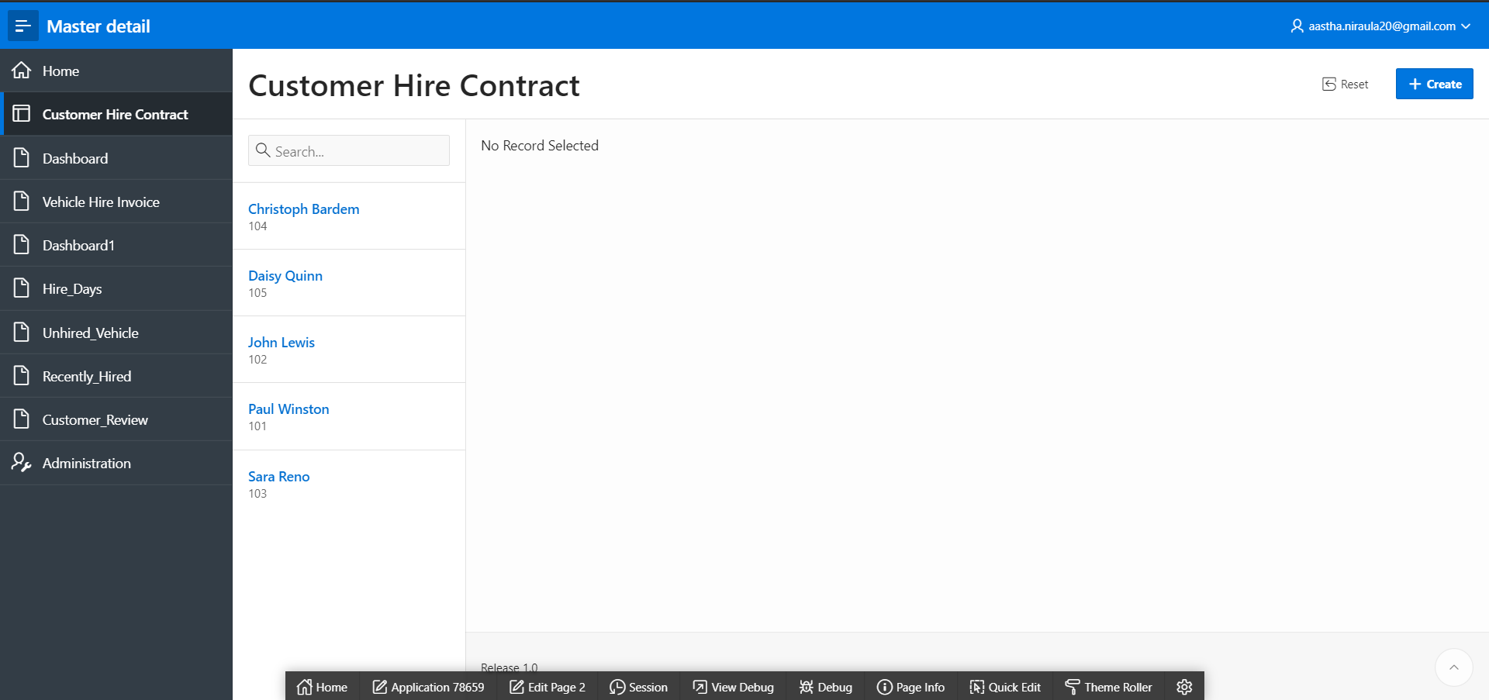

## Creating Sequence and Trigger

### Sequence and trigger for Customer ID

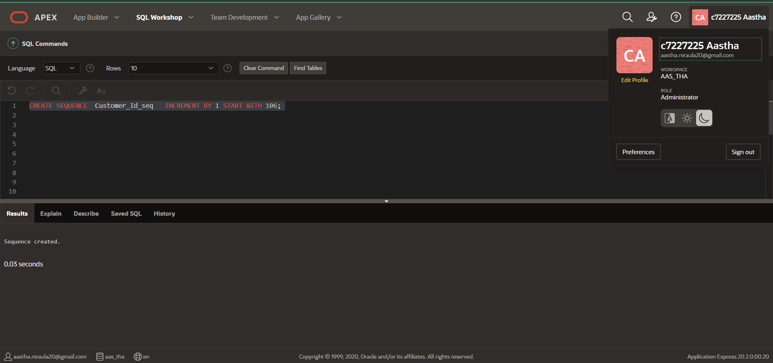

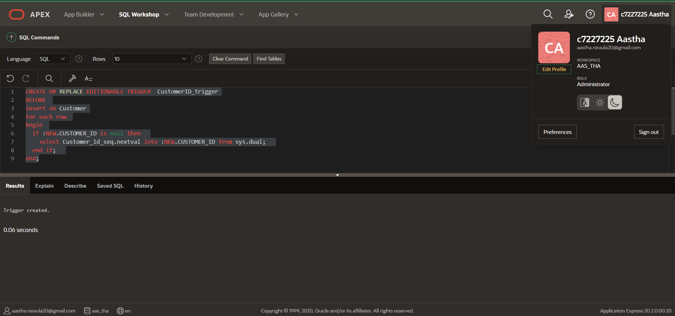

### Sequence and trigger for Hire Number

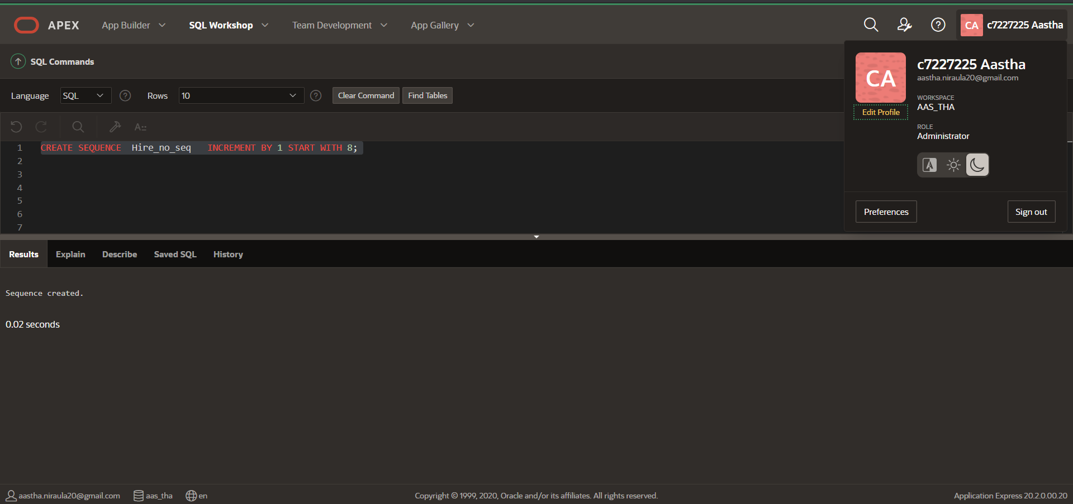

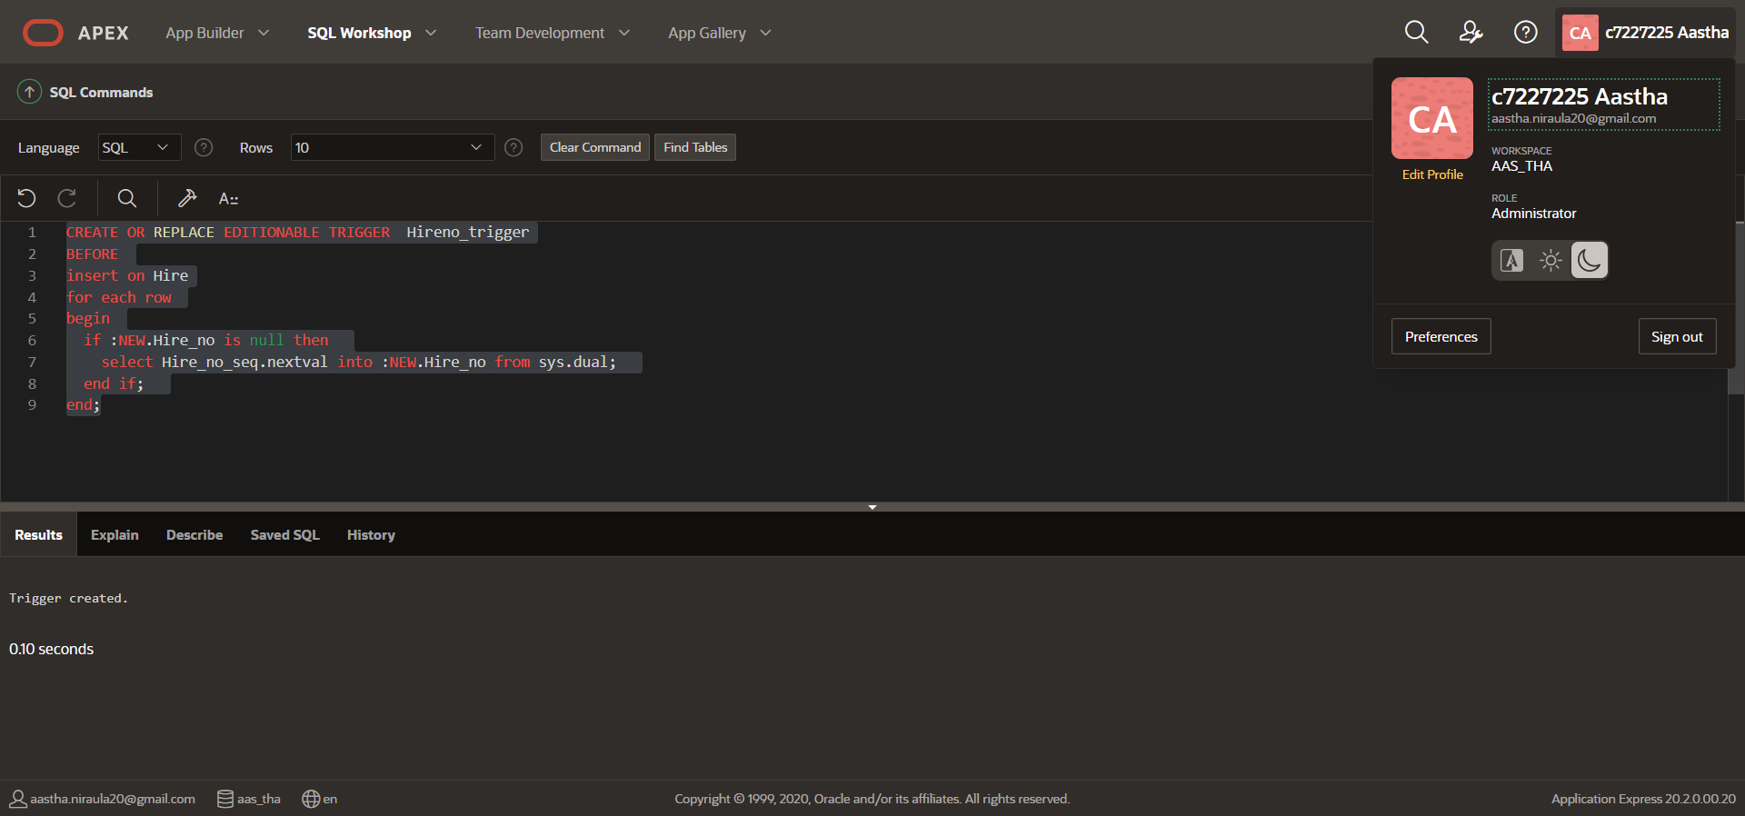

## CRUD Functionality

#### CREATE

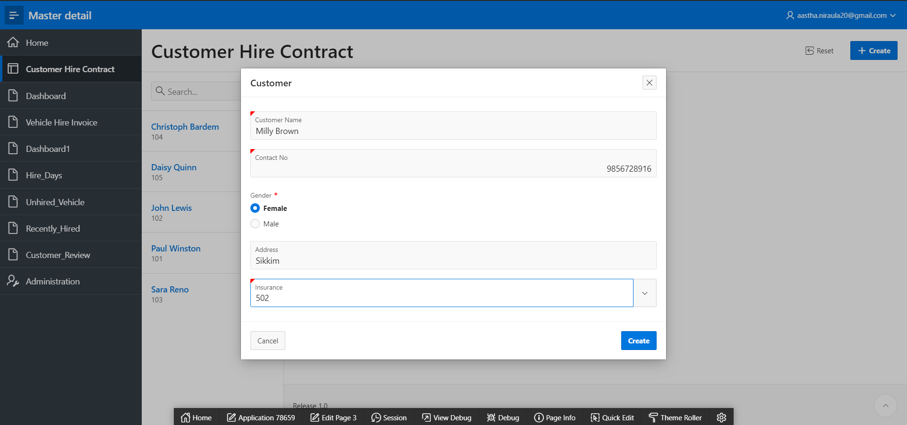

#### READ

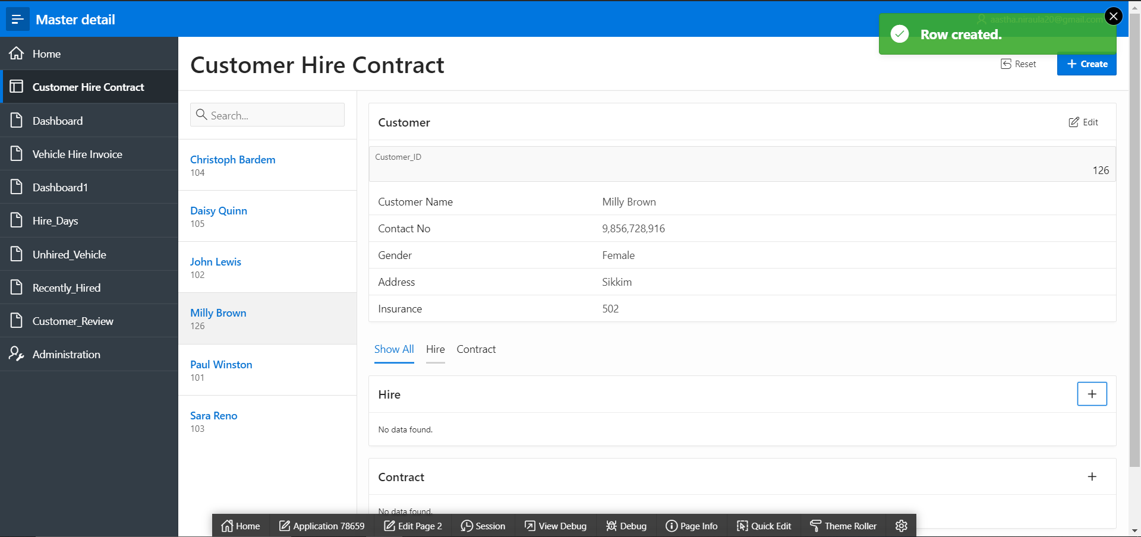

#### UPDATE

Changed insurance number and Gender of the customer

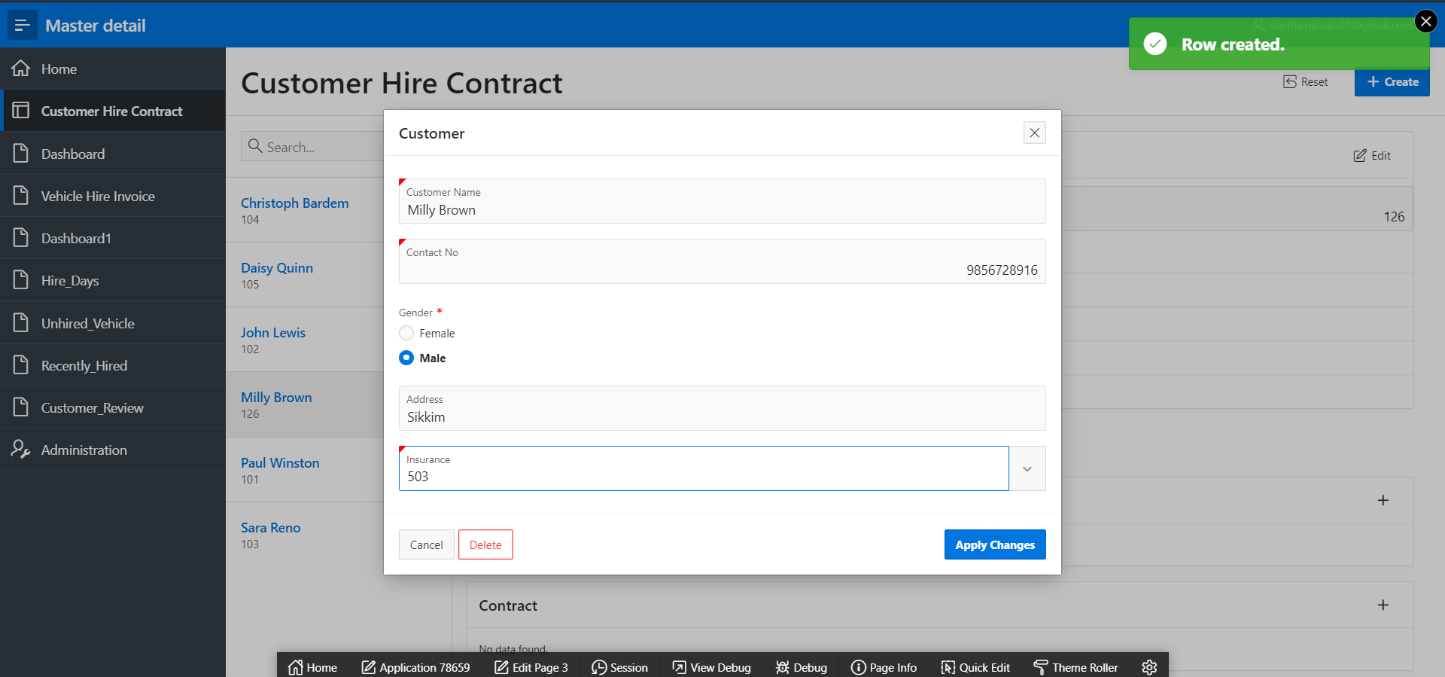

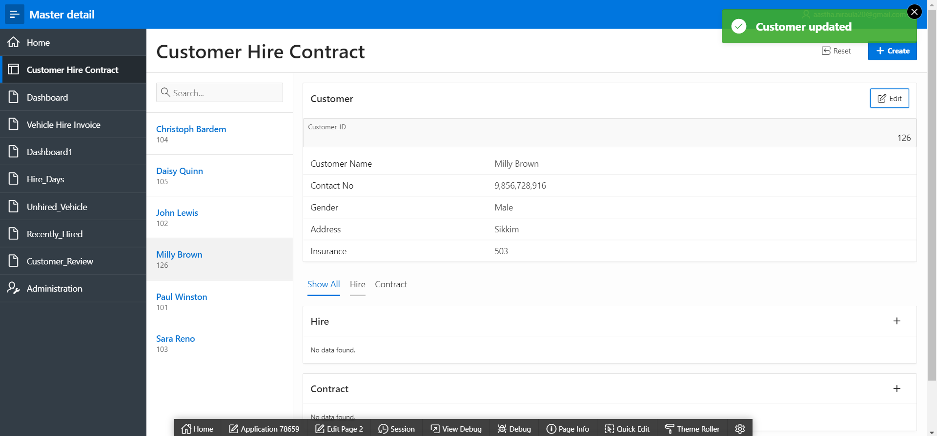

#### DELETE

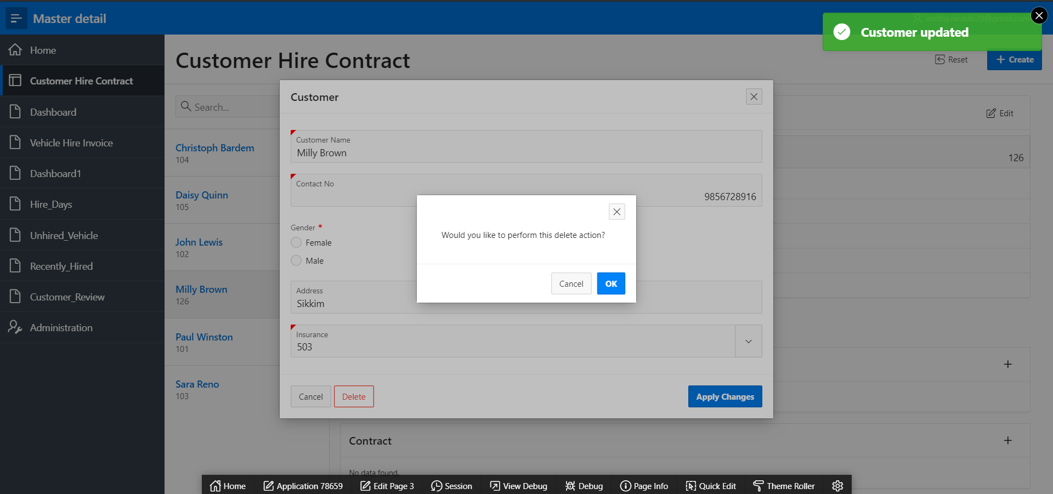

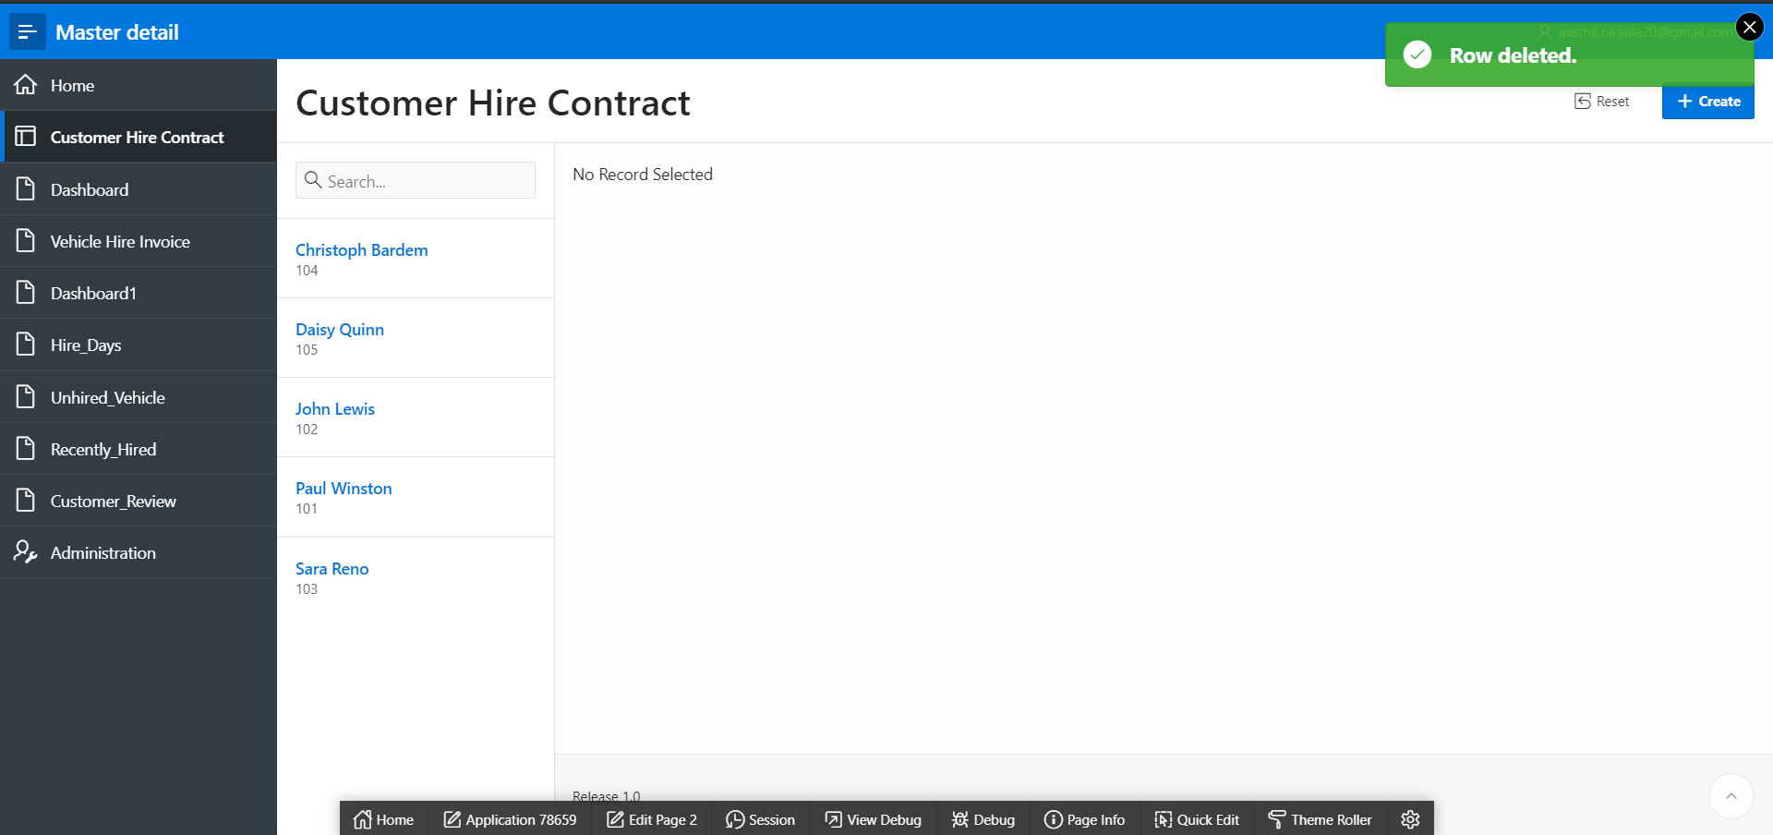

## 2. Master Detail for Vehicle, Hire and Invoice

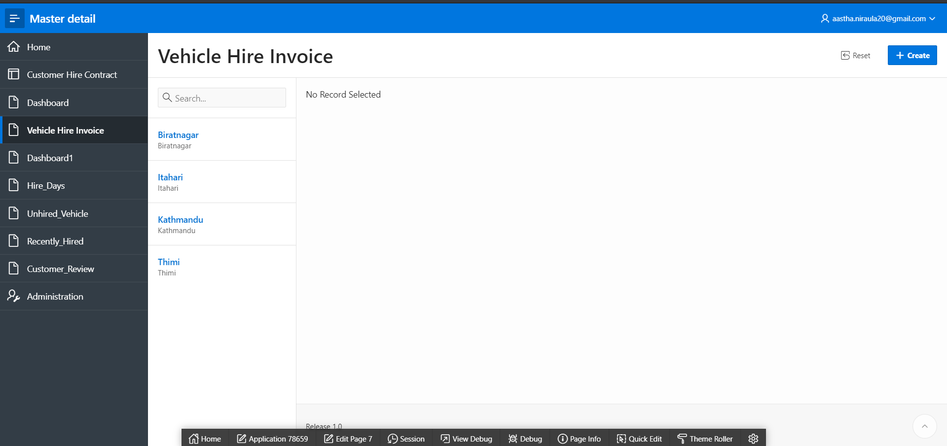

## 3. Dashboard for Vehicle, Hire and Invoice

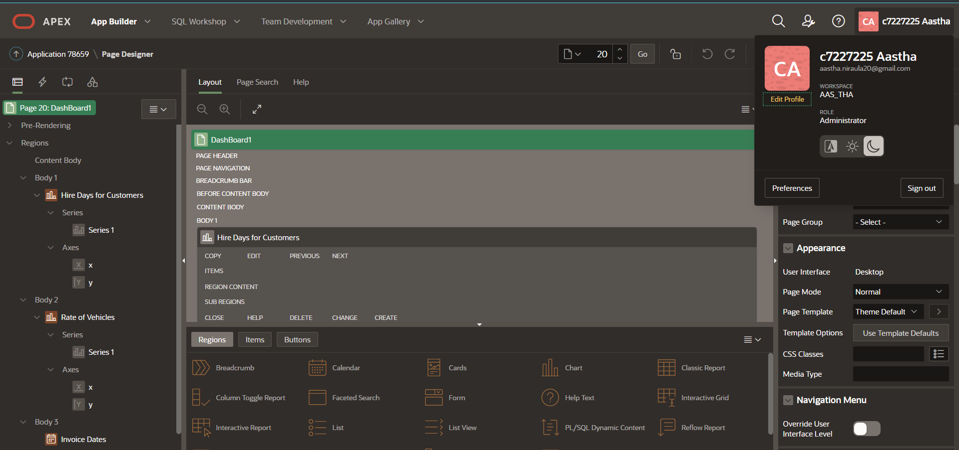

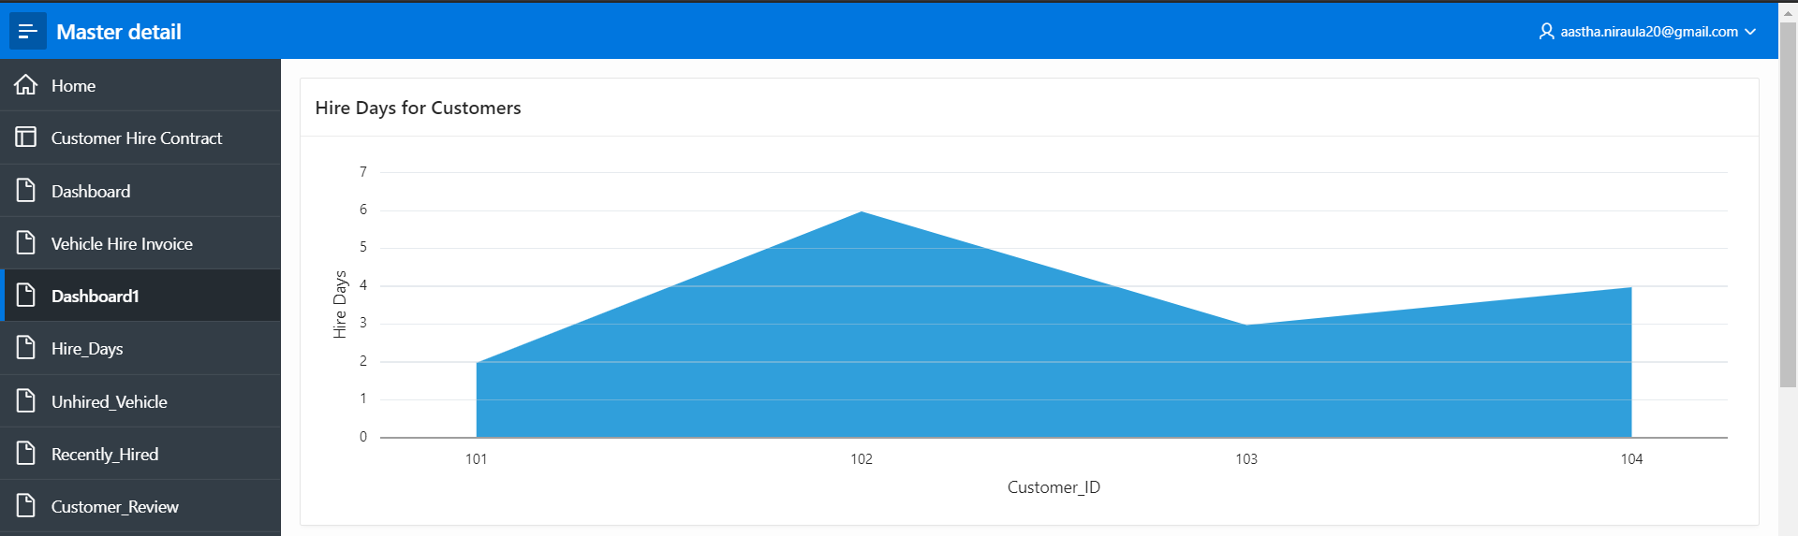

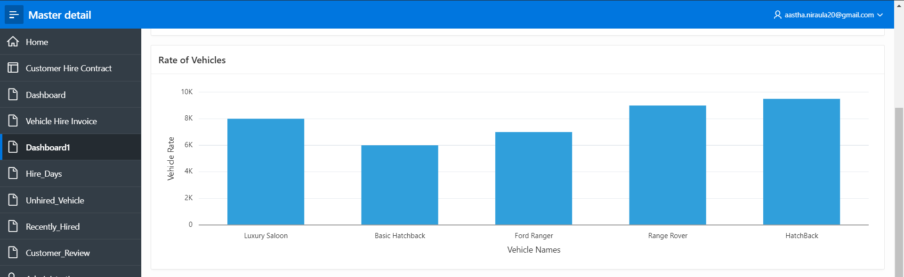

The calendar shows the hire number based on hire dates in the calendar.

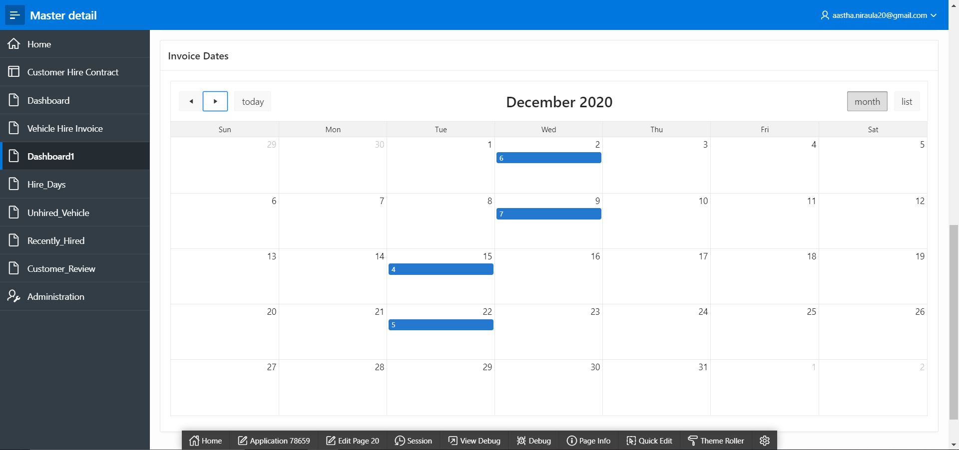

## 4. Dashboard for Customer based on Gender

Male: Female (3:2)

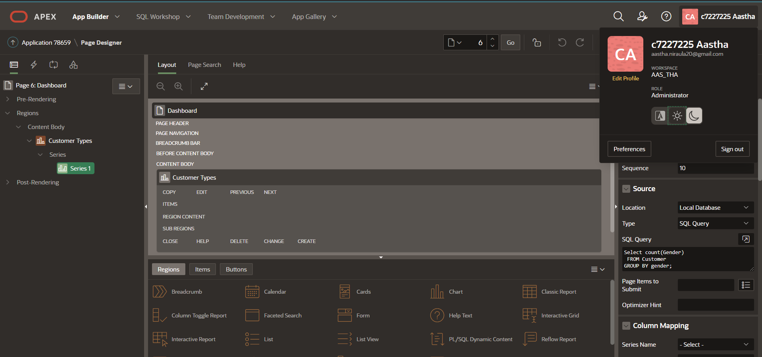

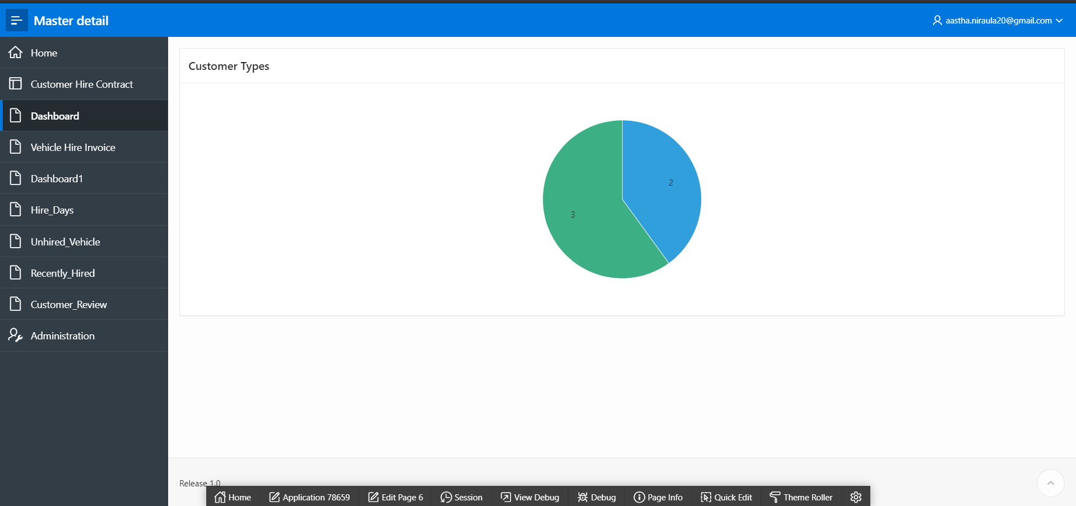

## 

## 5. Using APEX Functionality

### a. Using Radio Group

For customer’s gender in customer table:

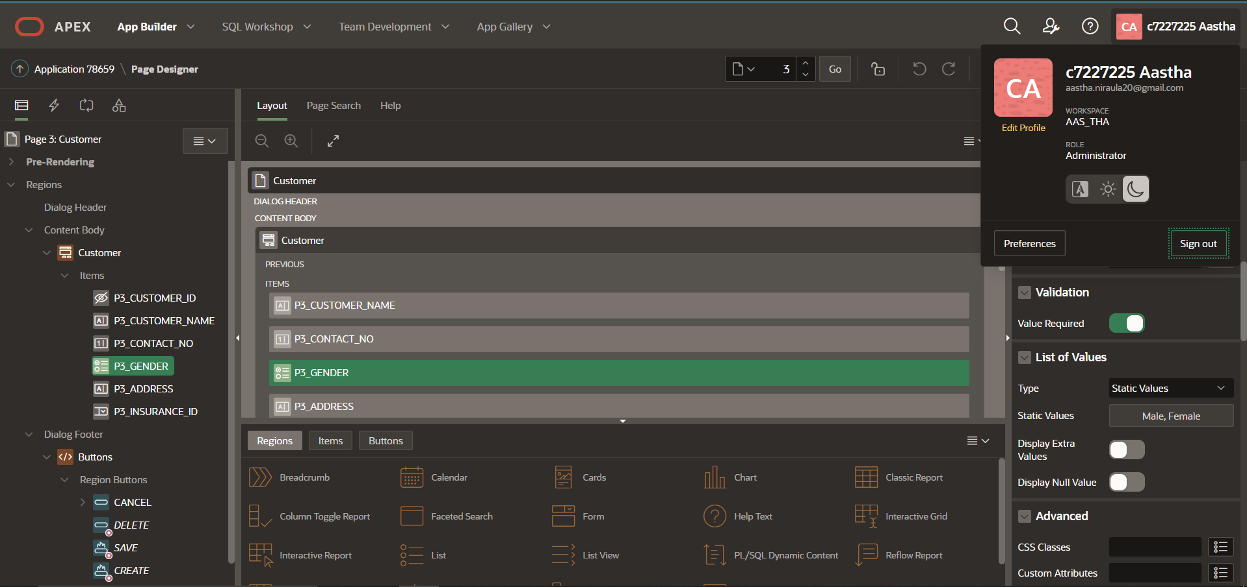

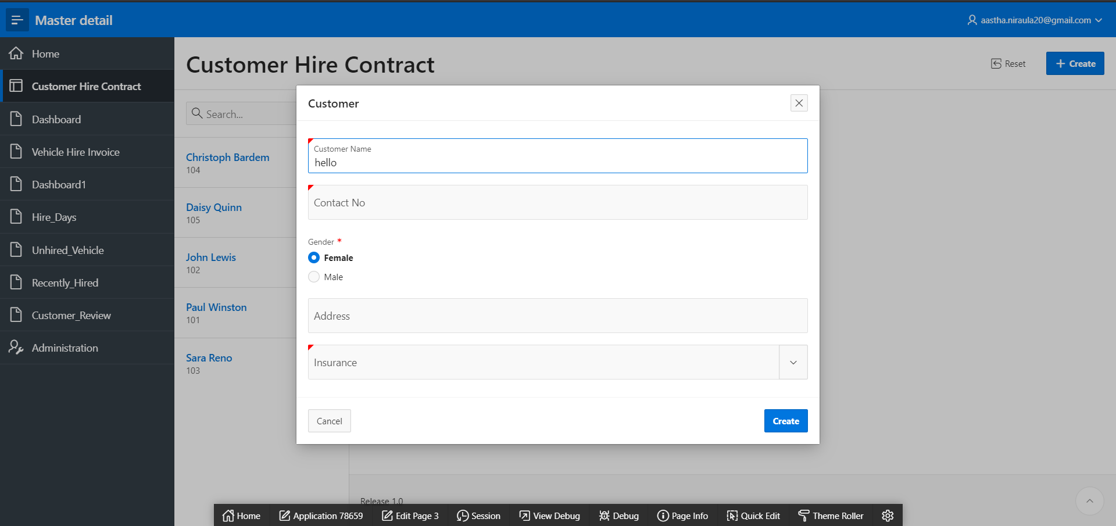

### b. Using Popup LOV and adding SQL command

#### For insurance:

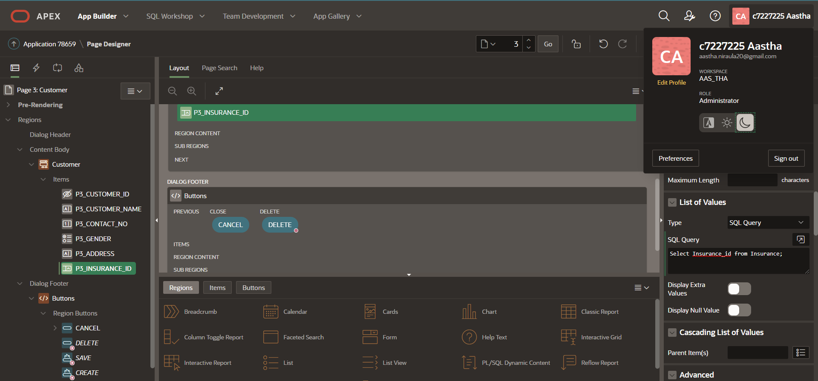

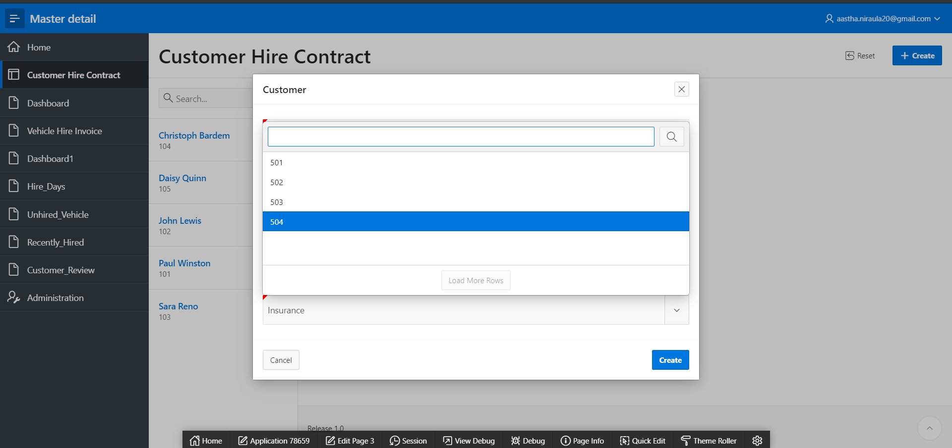

#### For Hire:

Customer ID

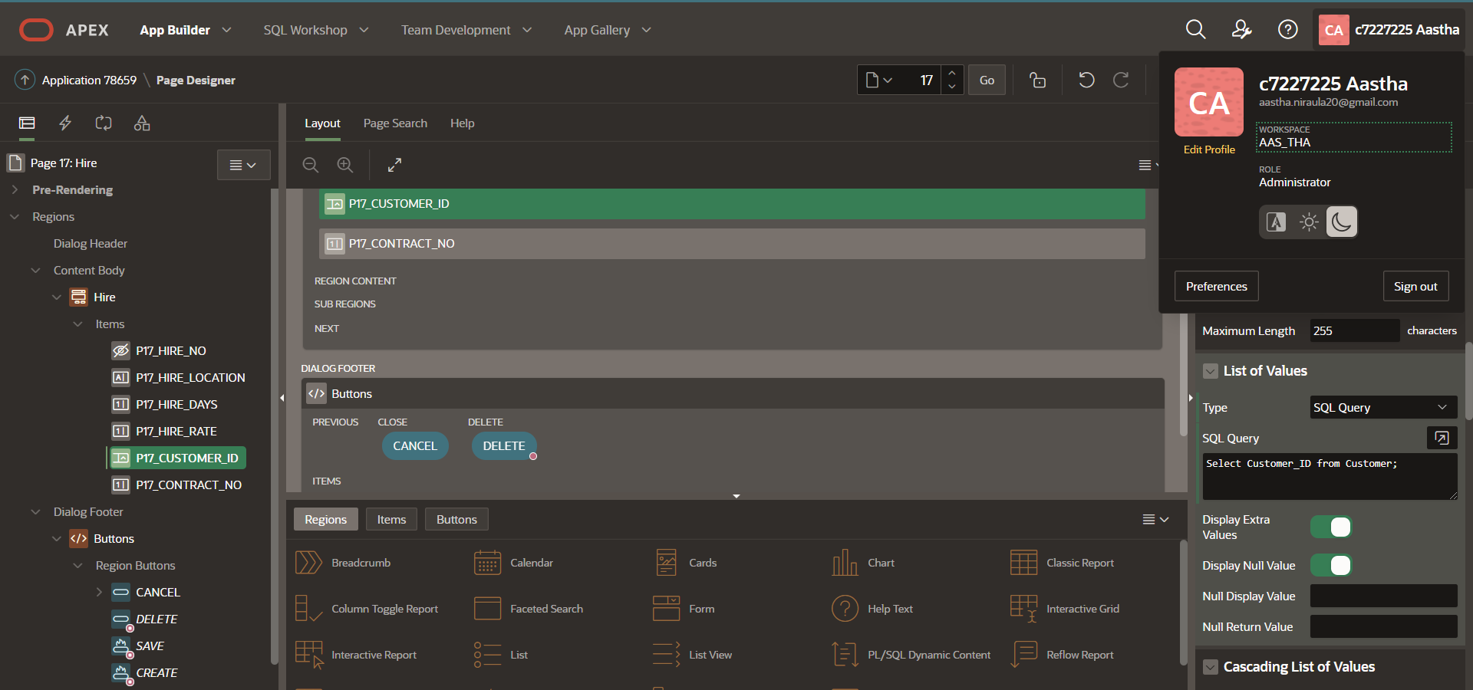

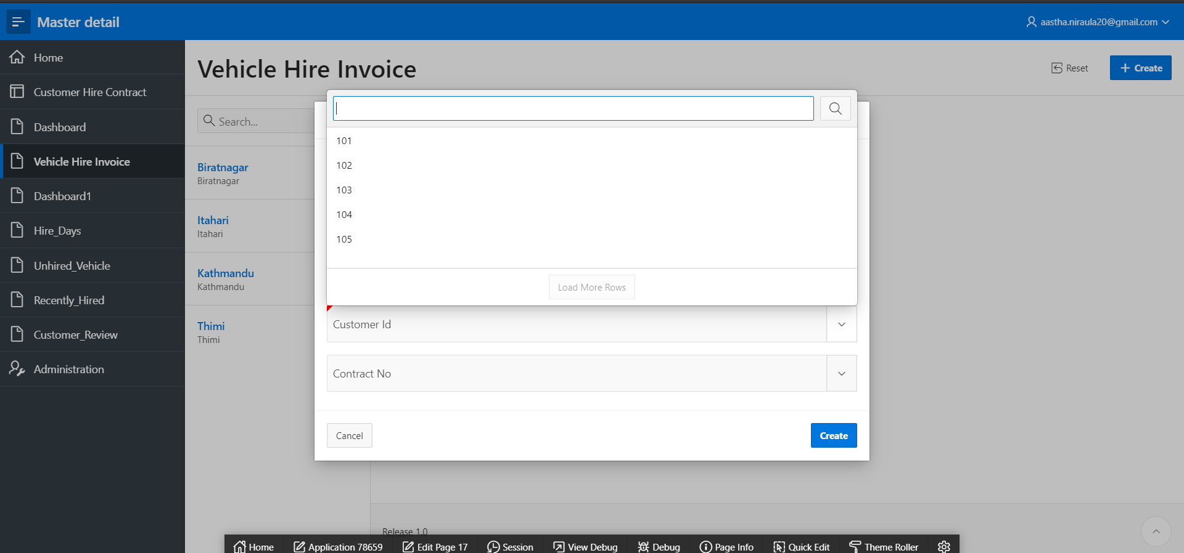

Contract number:

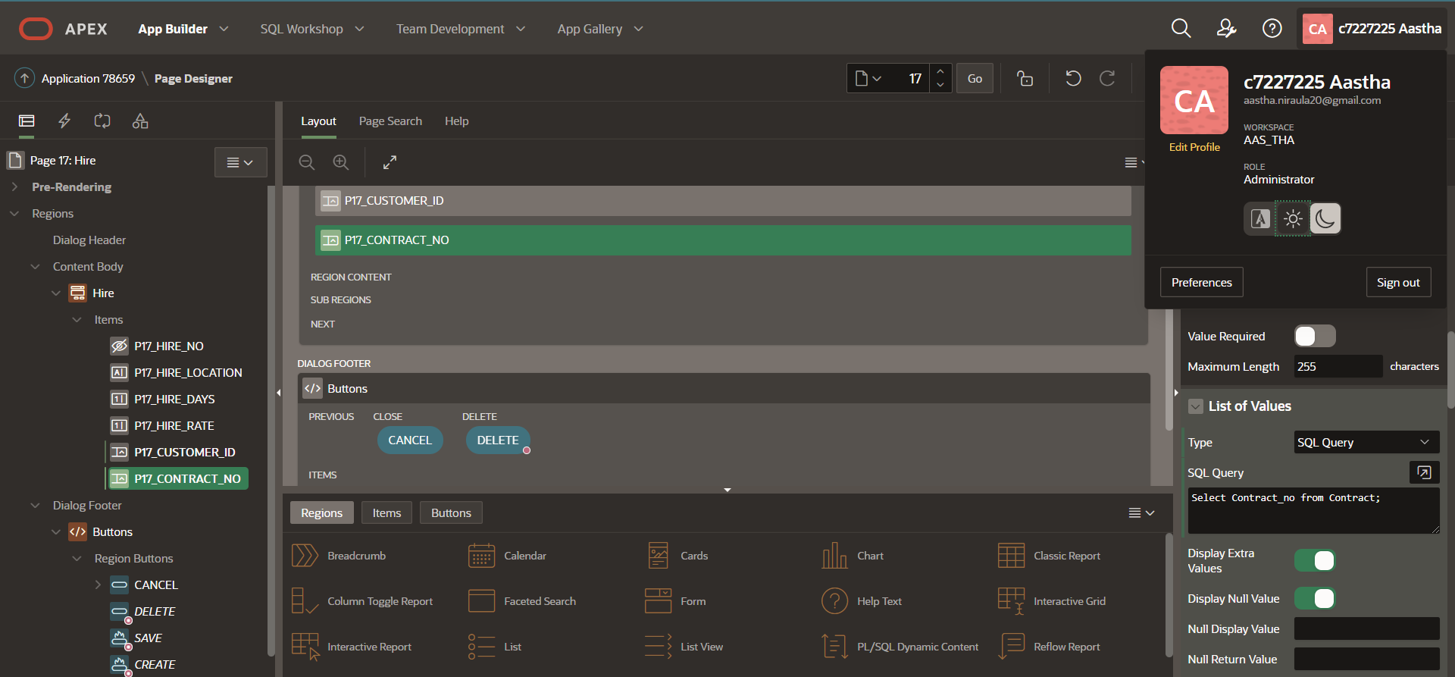

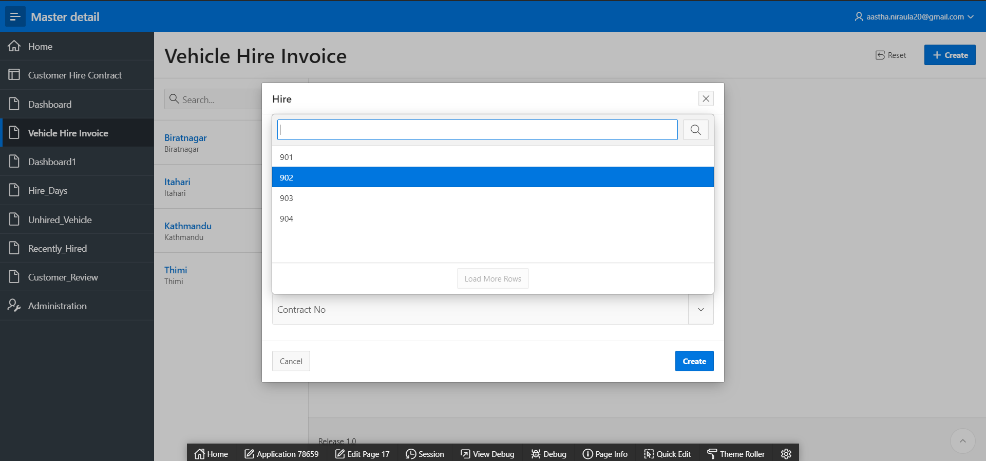

## 6. Required Fields

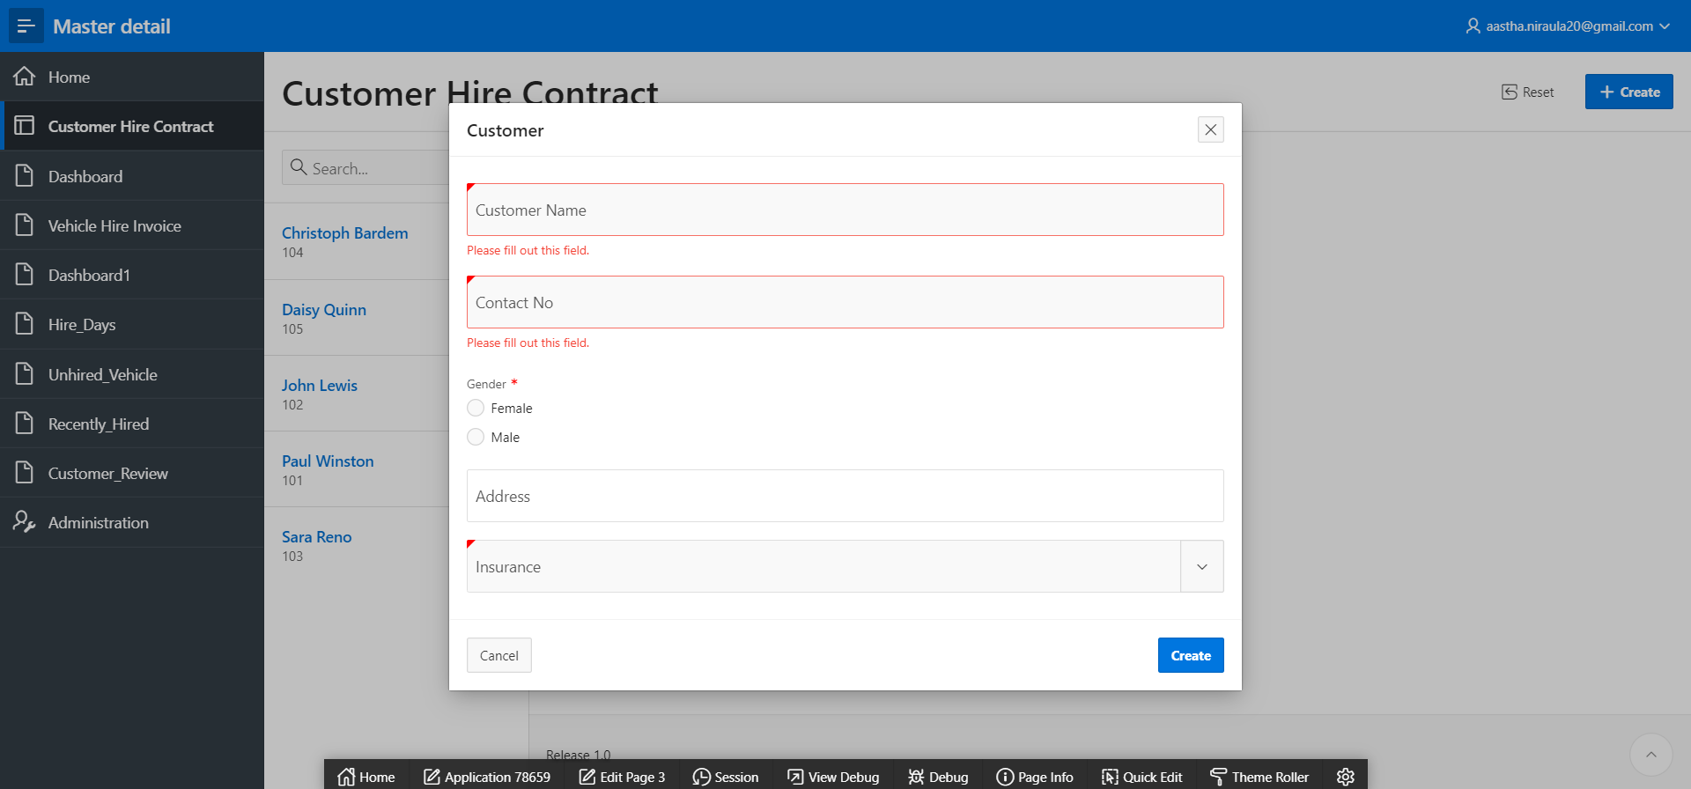

## 7. User login

### Creating Users

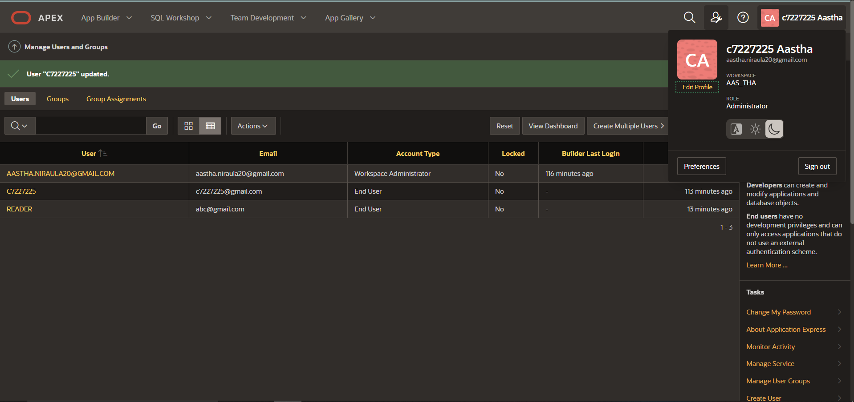

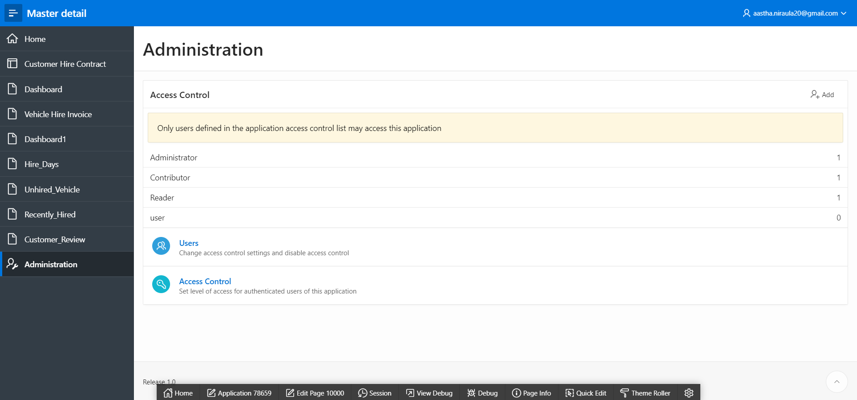

### Editing the Actions

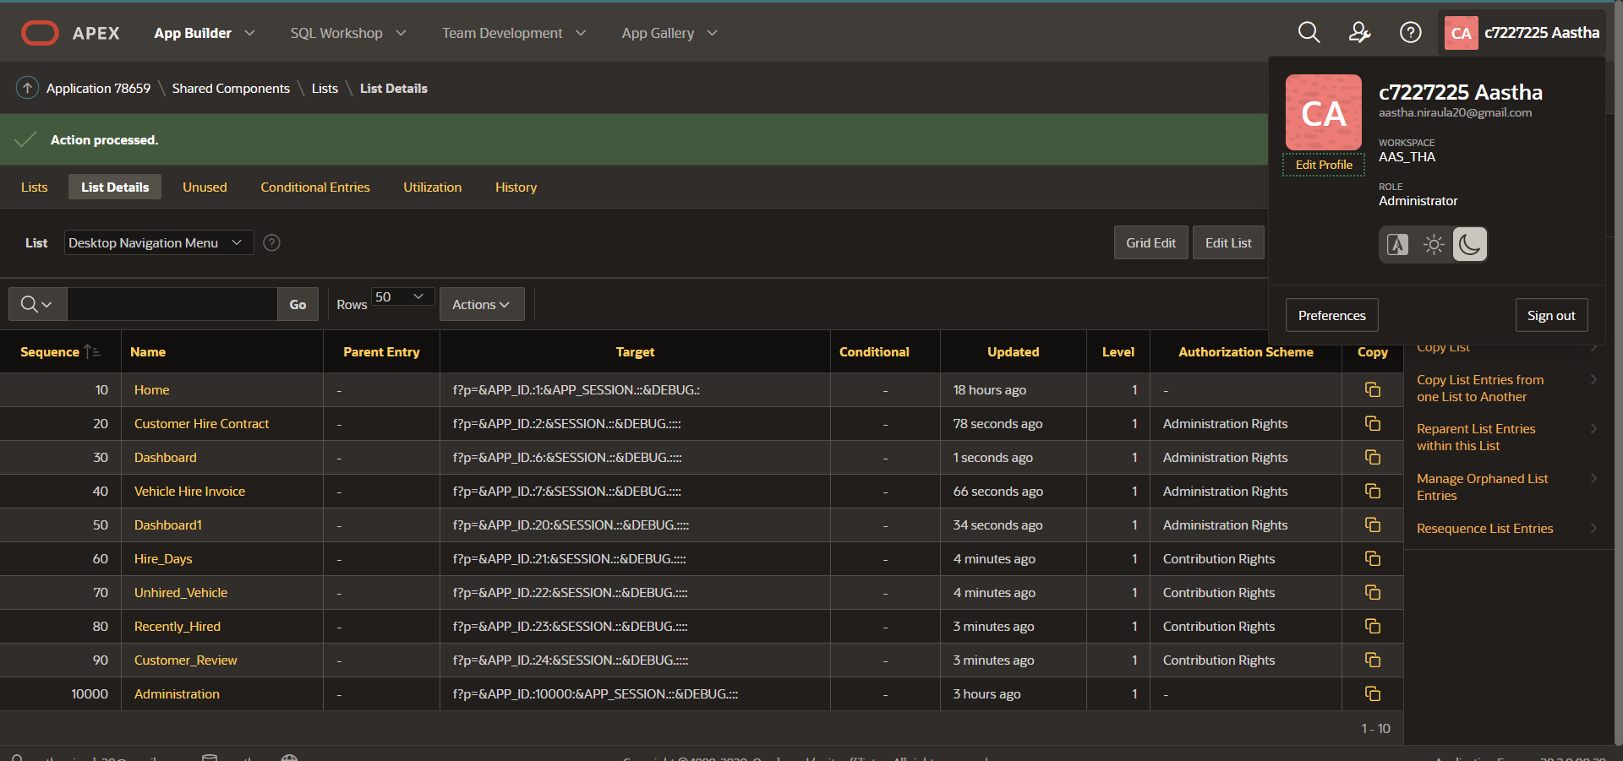

#### For Administrator

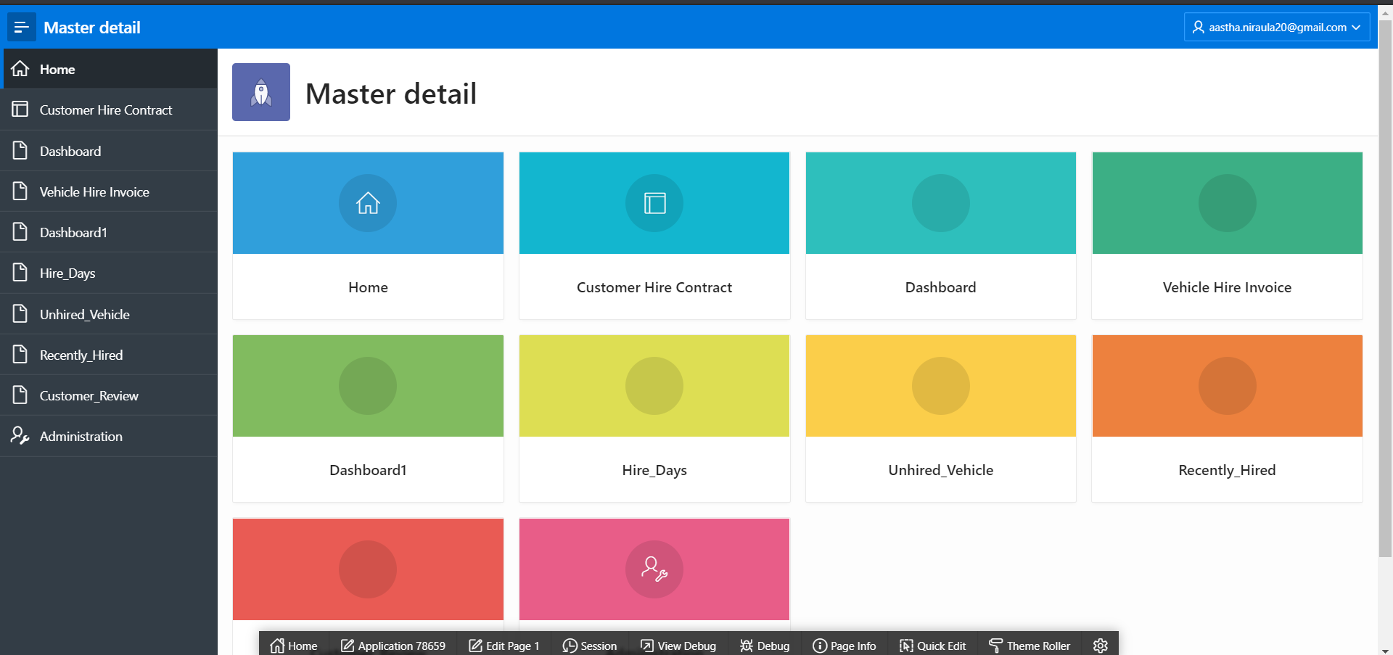

#### For Contributor

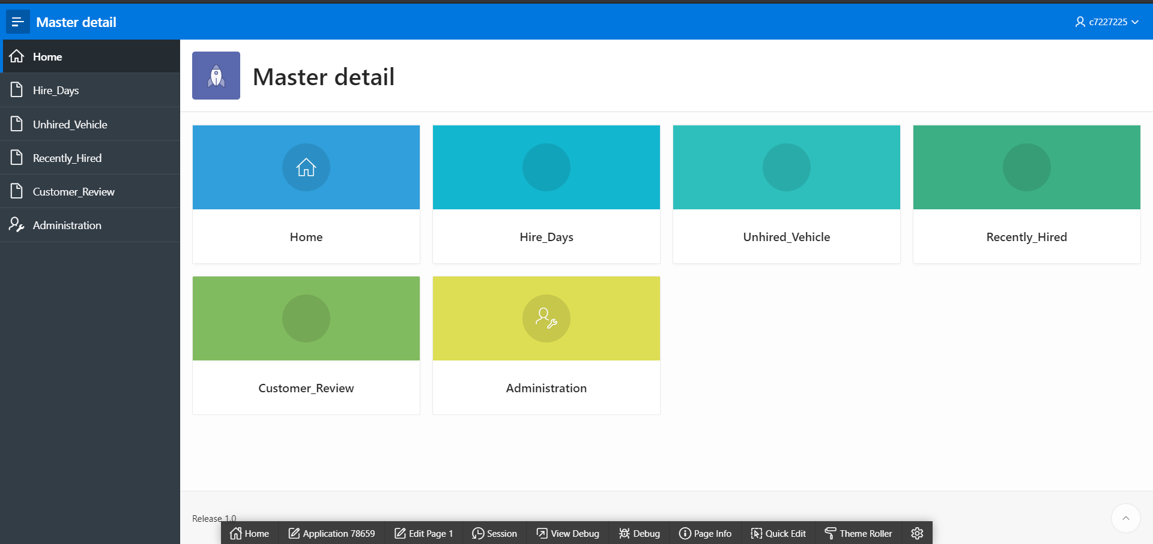

# Bibliography

Connolly, Thomas M (2015). *Database systems: a practical approach to design, implementation and management.* Sixth Edition. England: Pearson Education Limited.

Oracle(2020) *Database Documentation* [Online]. Available at:

<https://docs.oracle.com/en/database/> (Accessed:29th December 2020)

# Appendixes

## TASK1:

### Trigger 1

DROP TABLE Customer_tmp CASCADE CONSTRAINTS;

CREATE TABLE Customer_tmp (

Customer_ID NUMBER(10),

Customer_Name VARCHAR(30) ,

Contact_no NUMBER(20),

Gender CHAR(7),

Address VARCHAR(30),

a_user VARCHAR2(30),

a_date DATE,

a_action VARCHAR2(30)

);

DROP TRIGGER Customer_trigger;

CREATE OR REPLACE TRIGGER Customer_trigger

AFTER INSERT OR DELETE OR UPDATE ON Customer

FOR EACH ROW

DECLARE

--variable for declaring update, delete or insert

vc_trigger_action VARCHAR2(30);

BEGIN

IF updating

THEN

-- incase of updating

vc_trigger_action := 'Data UPDATE';

ELSIF inserting

THEN

-- incase of inserting

vc_trigger_action := 'Data INSERT';

ELSIF deleting

THEN

-- incase of deleting

vc_trigger_action := 'Data DELETE';

END IF;

IF vc_trigger_action IN ('Data DELETE','Data UPDATE') THEN

-- if vc_trg_action is DELETE or UPDATE then insert old table values

INSERT INTO Customer_tmp

(Customer_ID,Customer_Name,Contact_no,Gender,Address,a_user ,a_date,a_action)

VALUES

(:OLD.Customer_ID, :OLD.Customer_Name, :OLD.Contact_no,:OLD.Gender,:OLD.Address,v('APP_USER'), SYSDATE, vc_trigger_action);

ELSE

-- if vc_trg_action is INSERT then insert new table values

INSERT INTO Customer_tmp

(Customer_ID,Customer_Name,Contact_no,Gender,Address,a_user ,a_date,a_action)

VALUES

(:NEW.Customer_ID, :NEW.Customer_Name, :NEW.Contact_no,:NEW.Gender,:NEW.Address,UPPER(v('APP_USER')), SYSDATE, vc_trigger_action);

END IF;

END customer_trigger;

### Testing

INSERT INTO CUSTOMER VALUES (105,'Daisy Quinn',9835728190 ,'Female','Taplejung',502);

INSERT INTO CUSTOMER VALUES (145,'Unique Laun',9754278910,'Male','Thapathali',501);

UPDATE Customer

set customer_name='Lucky'

where customer_id=145;

DELETE FROM Customer

WHERE customer_id=145;

SELECT * FROM Customer_tmp;

### Additional Trigger

CREATE TABLE insurance_tmp as select * from insurance;

CREATE TABLE customer_tmp as select * from customer;

CREATE OR REPLACE TRIGGER insurance_null

AFTER DELETE OR UPDATE OF insurance_id on insurance_tmp

FOR EACH ROW

BEGIN

IF UPDATING AND :OLD.insurance_id!= :NEW.insurance_id THEN

UPDATE customer_tmp SET insurance_id=NULL

WHERE customer_tmp.insurance_id = :old.insurance_id;

END IF;

END;

### Testing

UPDATE insurance_tmp SET insurance_id=503

WHERE insurance_id=501;

SELECT * FROM insurance_tmp;

DELETE FROM insurance_tmp

WHERE insurance_id=502;

SELECT * FROM insurance_tmp;

### Trigger 2

CREATE TABLE Company_holidays (Day DATE);

INSERT INTO Company_holidays VALUES ('12/25/2020');

INSERT INTO Company_holidays VALUES ('12/26/2020');

INSERT INTO Company_holidays VALUES ('1/1/2021');

INSERT INTO Company_holidays VALUES ('12/31/2020');

CREATE OR REPLACE TRIGGER Holidays_trigger

BEFORE INSERT OR DELETE OR UPDATE ON Contract

DECLARE

holiday INTEGER;

Not_on_holidays EXCEPTION;

BEGIN

/* Check for company holidays: */

SELECT COUNT(*) INTO holiday FROM Company_holidays

WHERE TRUNC(Day) = TRUNC(Sysdate); -- Discard time parts of dates

IF holiday > 0 THEN

RAISE Not_on_holidays;

END IF;

EXCEPTION

WHEN Not_on_holidays THEN

Raise_application_error(-20325,'Might not change '

||'employee table during a holiday');

END;

### Testing

INSERT INTO Contract values (901,'06/06/2020','12/31/2020',101,6784);

## TASK 2:

### Report1

SELECT c.Customer_ID, c.Customer_name, h.hire_days

FROM Customer c, Hire h

WHERE c.customer_id=h.customer_id

AND hire_days>1

ORDER BY Hire_days;

### Report2

SELECT v.vehicle_no, v.classification, v.model, v.charge, h.hire_no

FROM vehicles v, hire h

WHERE h.hire_no (+) = v.hire_no

AND v.hire_no is NULL;

### Report3

SELECT contract_no, start_date, customer_id

FROM contract

WHERE (start_date,customer_id)

IN

(SELECT MAX(start_date), customer_id FROM contract

GROUP BY customer_id);

### Report4

SELECT ct.customer_id,c.customer_name,c.contact_no, ct.Contract_no, ct.end_date, add_months(end_date,2) review_date

FROM contract ct INNER JOIN customer c

ON ct.customer_id=c.customer_id

ORDER BY add_months(end_date,2);

## SEQUENCE AND TRIGGERS

CREATE SEQUENCE Customer_Id_seq INCREMENT BY 1 START WITH 106;

CREATE OR REPLACE EDITIONABLE TRIGGER CustomerID_trigger

BEFORE

insert on Customer

for each row

begin

if :NEW.CUSTOMER_ID is null then

select Customer_Id_seq.nextval into :NEW.CUSTOMER_ID from sys.dual;

end if;

end;

CREATE SEQUENCE Hire_no_seq INCREMENT BY 1 START WITH 8;

CREATE OR REPLACE EDITIONABLE TRIGGER Hireno_trigger

BEFORE

insert on Hire

for each row

begin

if :NEW.Hire_no is null then

select Hire_no_seq.nextval into :NEW.Hire_no from sys.dual;

end if;

end;